Supplementary materials for “Quantifying fine-scale heterogeneity in wildland fuels”

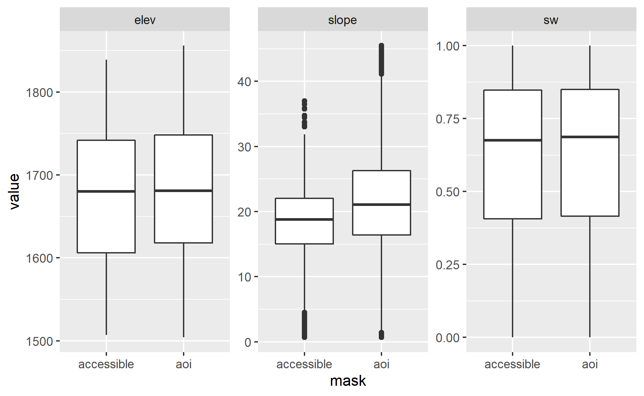
Supplementary Figure 1: Comparison of elevation, slope, and southwestness index between the entire area of interest (CALVEG-mapped mixed conifer forest (pine) vegetation type between 1,500 and 1,850 m elevation in the vicinity of Crystal Cave Road in Sequoia National Park) and the subset of the area of interest which was accessible for sampling purposes (< 25° slopes and located 50-600 m from a road or trail). Histograms are of pixel values for topographic rasters derived from a 30.7 x 30.6 m resolution DEM. The distribution of topographic characteristics within the accessible area is very similar to the distribution of topographic characteristics within the entire area of interest, except that the accessible area has lower slopes on average. The pixels from the accessible area with a slope greater than 25 degrees were included because of edge artifacts when converting between raster and vector data types.

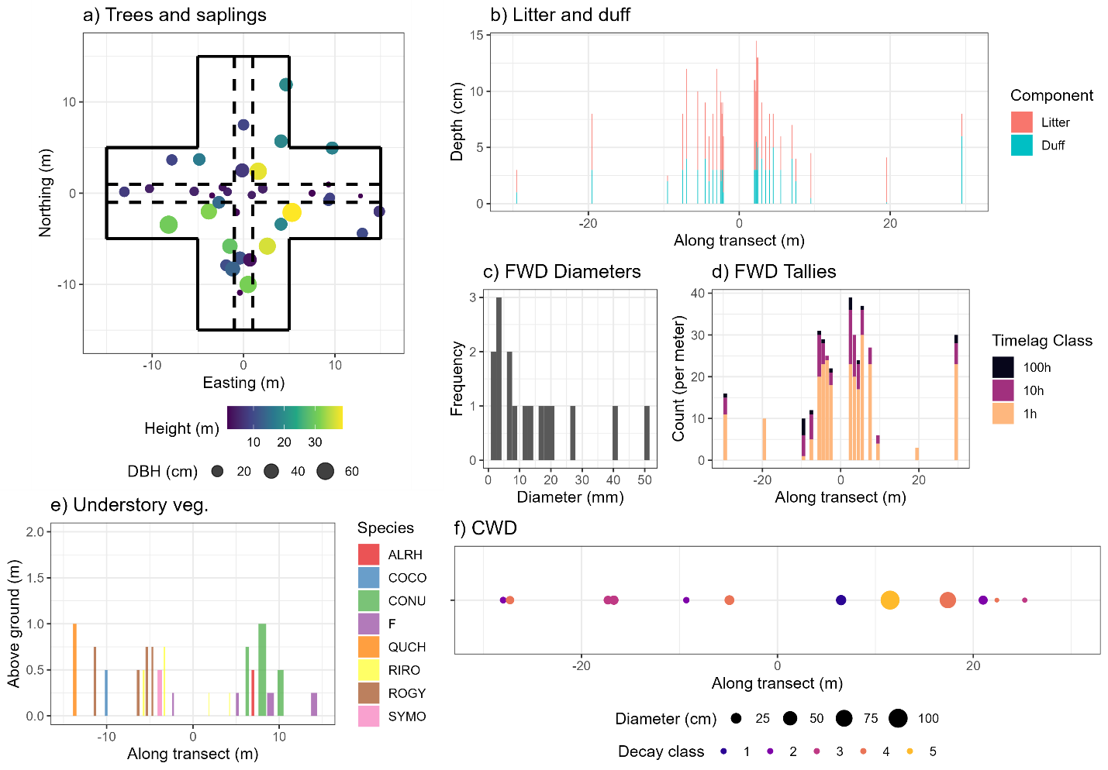
Supplementary Figure 2: Sample of observations from a single inventory plot. Panel a: Data on trees >= 11.4 cm DBH and saplings >= 1.37 m height include species, DBH, height, height to live crown, live/dead status, and spatial location within a 500 m² fixed area plot (trees) or a 116 m² fixed area plot (saplings). b: Depth of duff and litter was sampled at locations 2.0, 2.1, 2.2, 2.3, 2.4, 2.5, 3.0, 3.5, 4.0, 4.5, 5.5, 7.0, 7.5, 9.5, 19.5, and 29.5 m along each of four transects arranged at cardinal directions from plot center (data from East and West transects shown). c: From 9.0-10.0 m along each transect, diameter (mm) of each individual particle of fine woody debris intersecting the transect was recorded. d: Tally of 1-hour, 10-hour, and 100-hour fine woody debris particles intersecting two 1 m subtransects located at 2.5, 3.5, 4.5, 5.5, 7.5, 9.5, 19.5, and 29.5 m along each transect (data from East and West transects shown). e: Location, height, and species of dominant vegetation was recorded along four 15 m transects arranged at cardinal directions from plot center (data from East and West transects shown). f: Location, diameter, and decay class of coarse woody debris particles intersecting four 30 m transects arranged at cardinal directions from plot center were recorded (data from East and West transects shown).
Supplementary Figures 2, 3, 4: Exploratory Variograms: For co-located observations, the coefficient of correlation was calculated between observations from different components. The variograms were visually inspected for signs of spatially structured autocorrelation (between observations of the same fuel component) and spatially structured cross-correlation (between observations of different fuel components). Variograms were constructed separately for each drought severity class in case the relationships between components varied across these classes.
Most fuel components show strong evidence of spatial autocorrelation, with semi-variance values being lower at shorter distances and increasing with distance before reaching the sill and levelling off. The sole exception, for which variograms are ambiguous or reveal a lack of spatial autocorrelation for at least one drought mortality level, was litter depth. Only a few pairs of components show any evidence of cross-correlation. There is some evidence of cross-correlation between duff and litter, between 1-hour and 10-hour fine woody debris, and between 1-hour and 100-hour fine woody debris (Supplementary Figures 2, 3, and 4).
Across the entire dataset, the correlation coefficient between co-located observations of duff and litter is fairly weak at 0.19. The correlation between 1-hour and 10-hour fine woody debris tallies is stronger, at 0.50. Correlation between 1-hour and 100-hour fuels is weaker (0.10), as is correlation between 10-hour and 100-hour fuels (0.30). Direct correlation coefficients were not available for other pairs of components because the observations were not co-located.
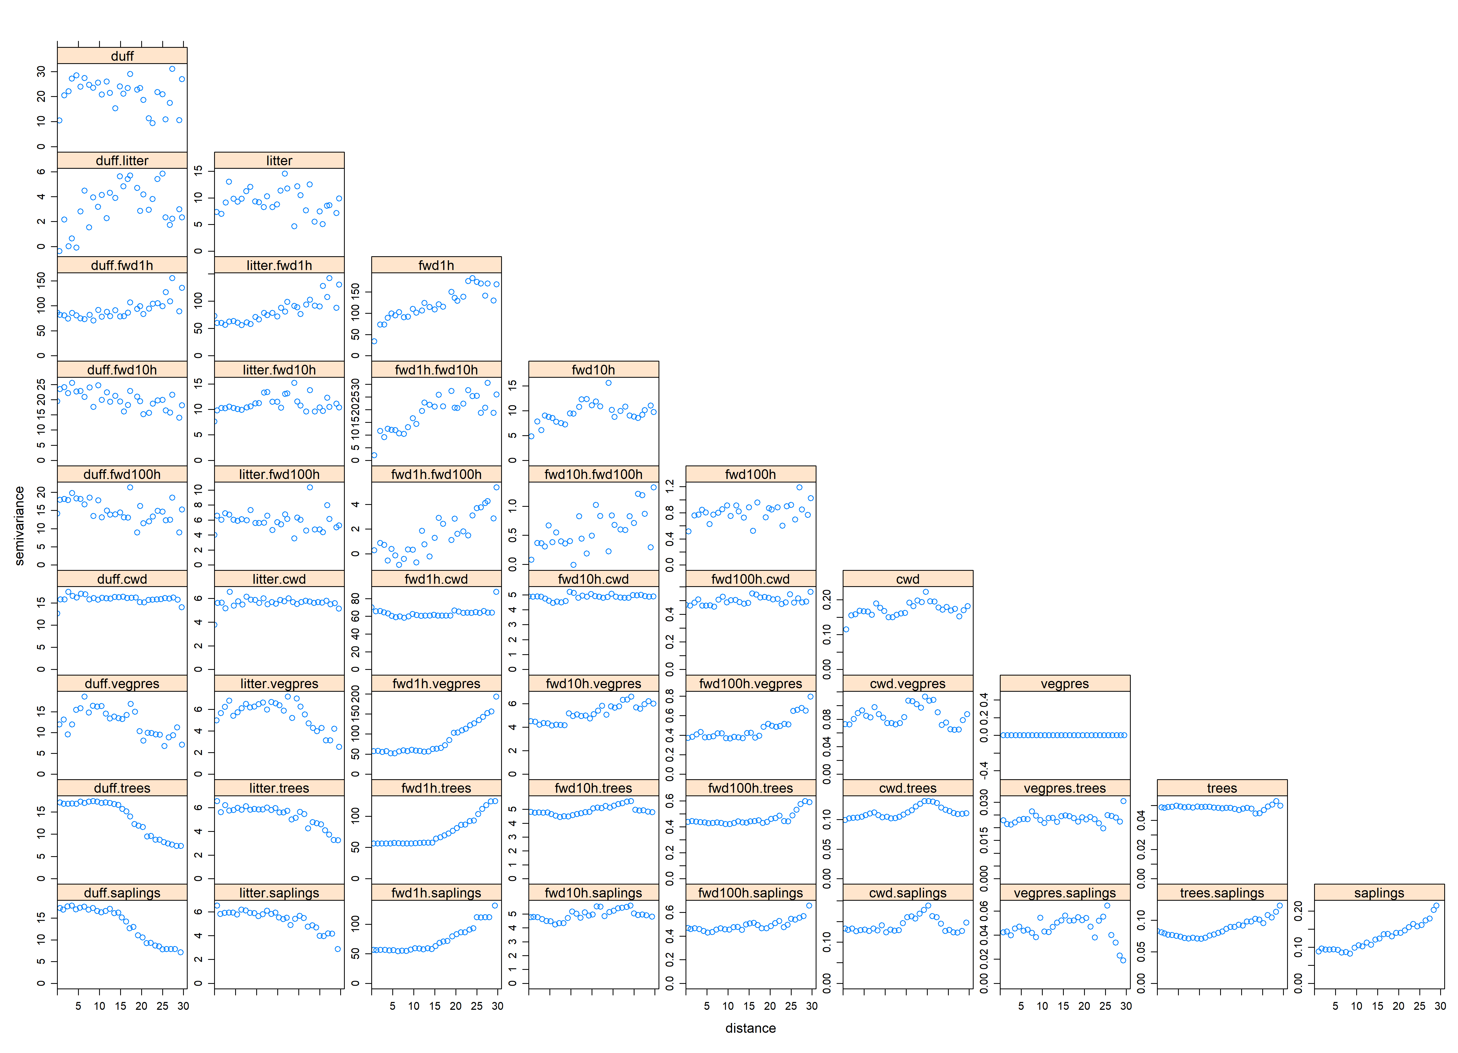
Supplementary Figure 3: Sample variograms for data from plots with low drought mortality. In each panel, the pairwise distance between observations (in meters) is on the x-axis and the semi-variance between observations at that distance (in 1-meter distance bins) is plotted on the y-axis. Increases in the semi-variance between observations as the distance between them increases are evidence of spatial autocorrelation. The variograms become noisier for distances above ~10m for which there are fewer pairs of observations. The diagonal panels show the variograms within each fuel component (spatial autocorrelation), and the off-diagonal panels show the cross-variograms between different fuel components (spatial cross-correlation). There is clear evidence of spatial autocorrelation for all fuel components except litter, vegetation presence, and trees, for which the variograms are ambiguous. There is noisy evidence of spatial cross correlation between duff and litter, between 1-hour and 100-hour fine woody debris, and between 10-hour and 100-hour fine woody debris. There is clear evidence of spatial cross correlation between 1-hour and 10-hour fine woody debris.

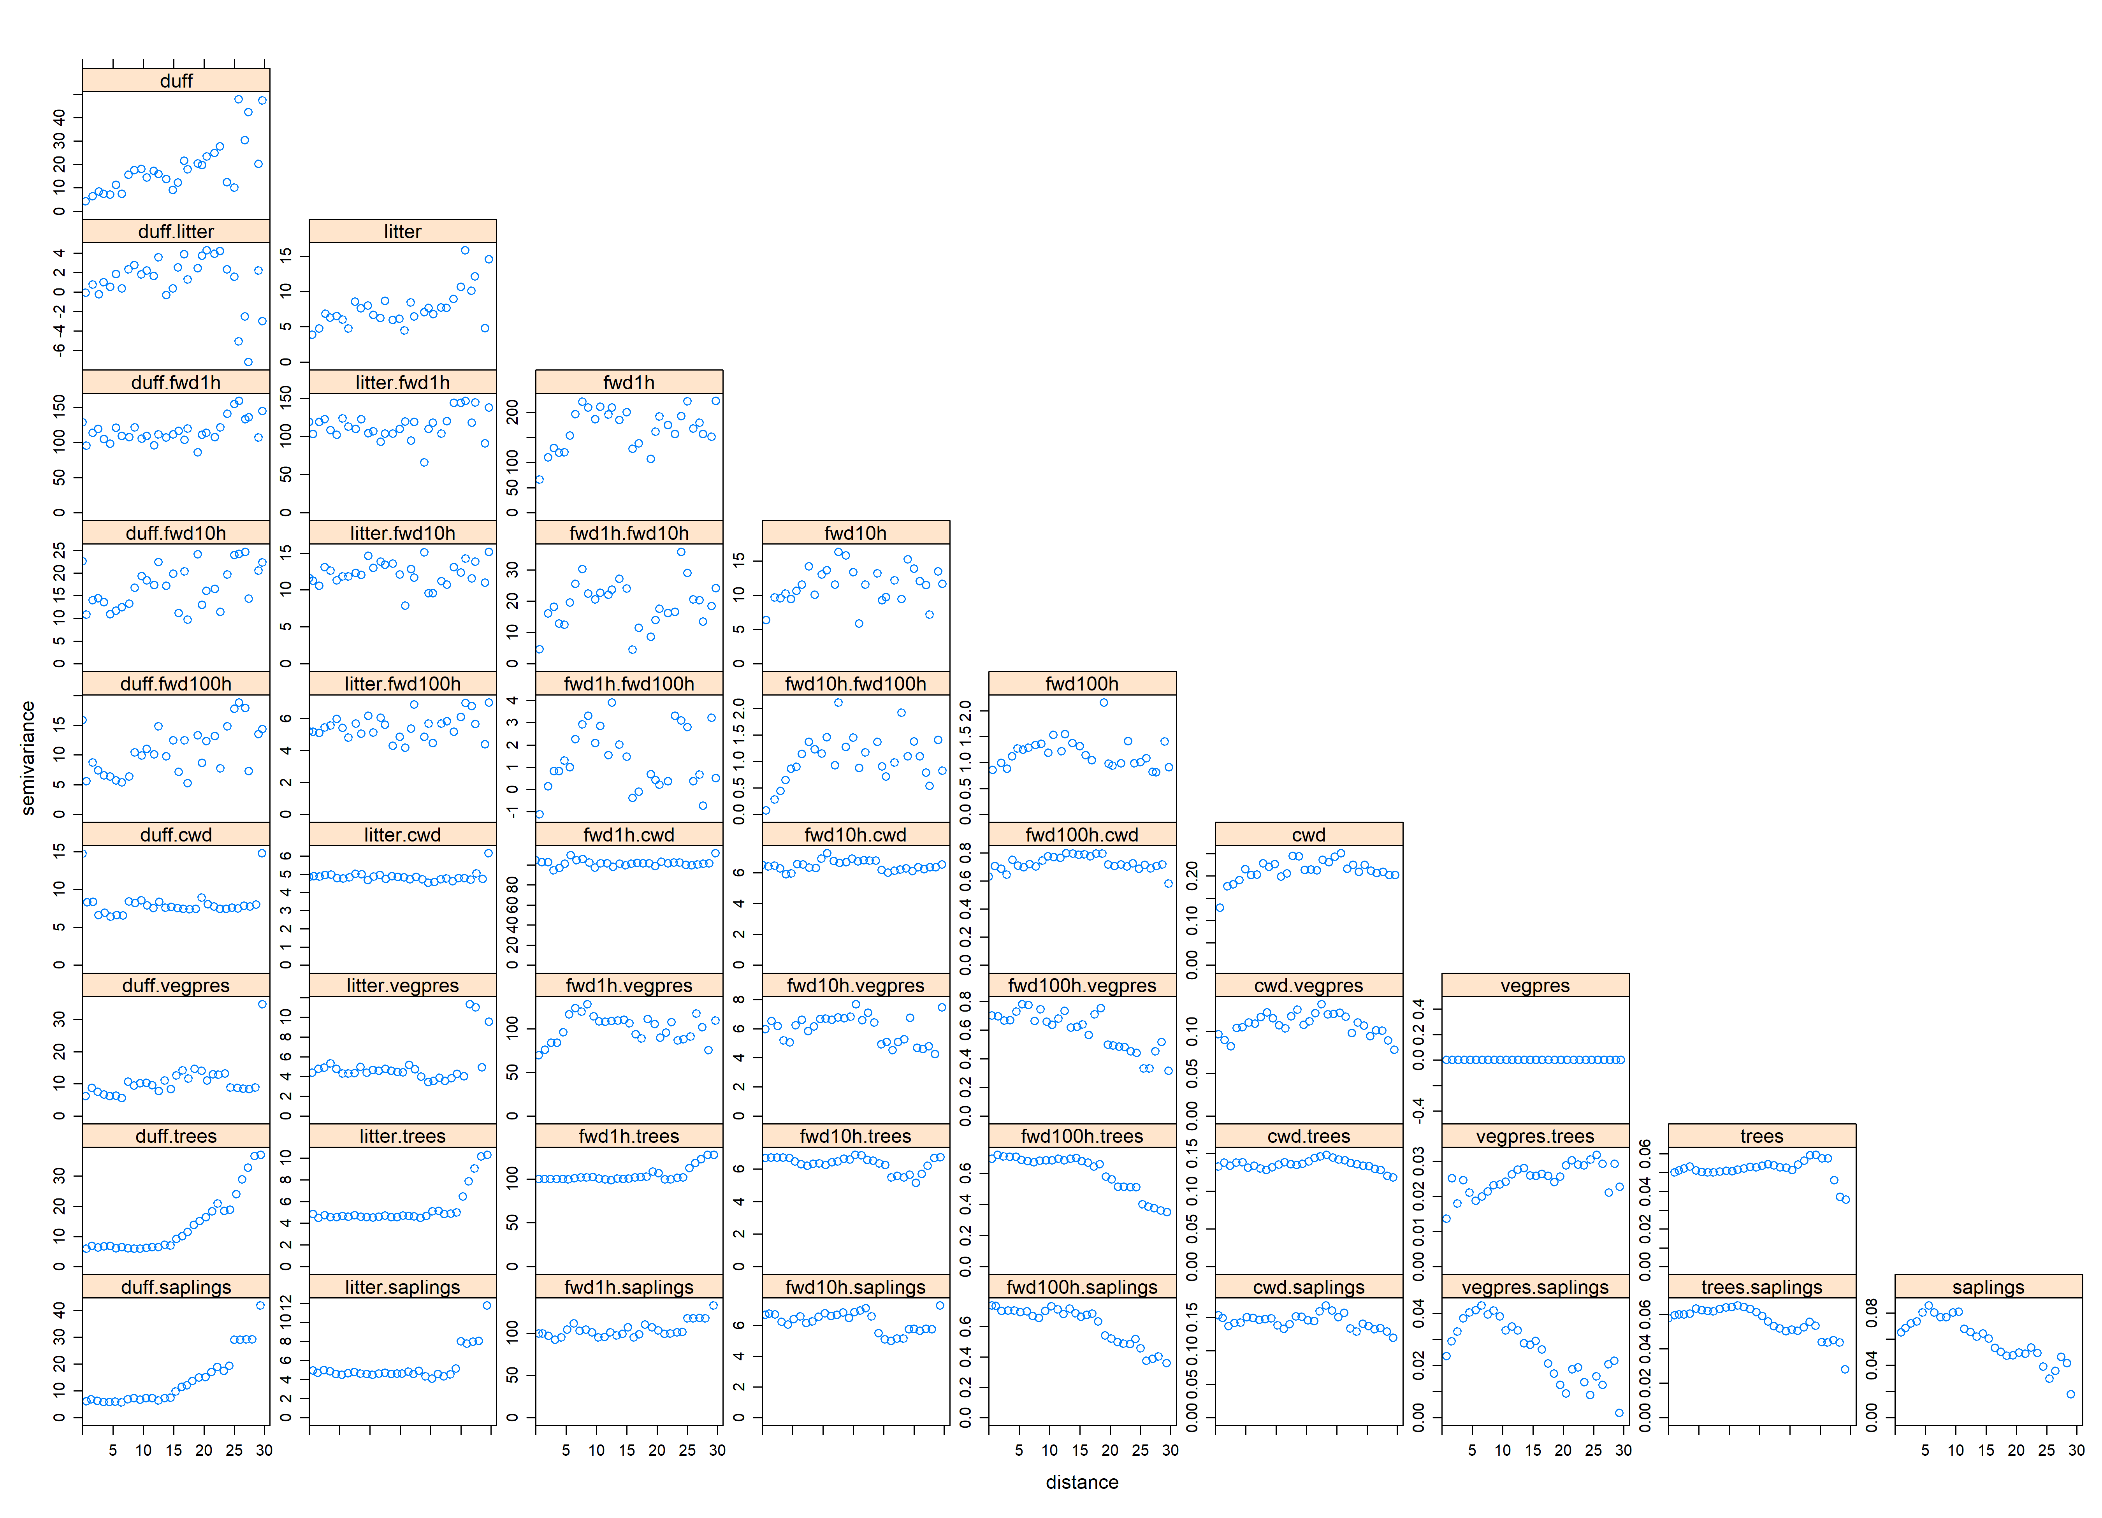
Supplementary Figure 4: Sample variograms for data from plots with medium drought mortality. In each panel, the pairwise distance between observations (in meters) is on the x-axis and the semi-variance between observations at that distance (in 1-meter distance bins) is plotted on the y-axis. Increases in the semi-variance between observations as the distance between them increases are evidence of spatial autocorrelation. The variograms become noisier for distances above ~10m for which there are fewer pairs of observations. The diagonal panels show the variograms within each fuel component (spatial autocorrelation), and the off-diagonal panels show the cross-variograms between different fuel components (spatial cross-correlation). There is clear evidence of spatial autocorrelation for all fuel components except vegetation presence, trees, and saplings. There is noisy evidence of spatial cross correlation between 1-hour and 10-hour fine woody debris and between 1-hour and 100-hour fine woody debris. There is clear evidence of spatial cross correlation between 10-hour and 100-hour fine woody debris, between 1-hour fine woody debris and vegetation presence, and between vegetation presence and saplings.

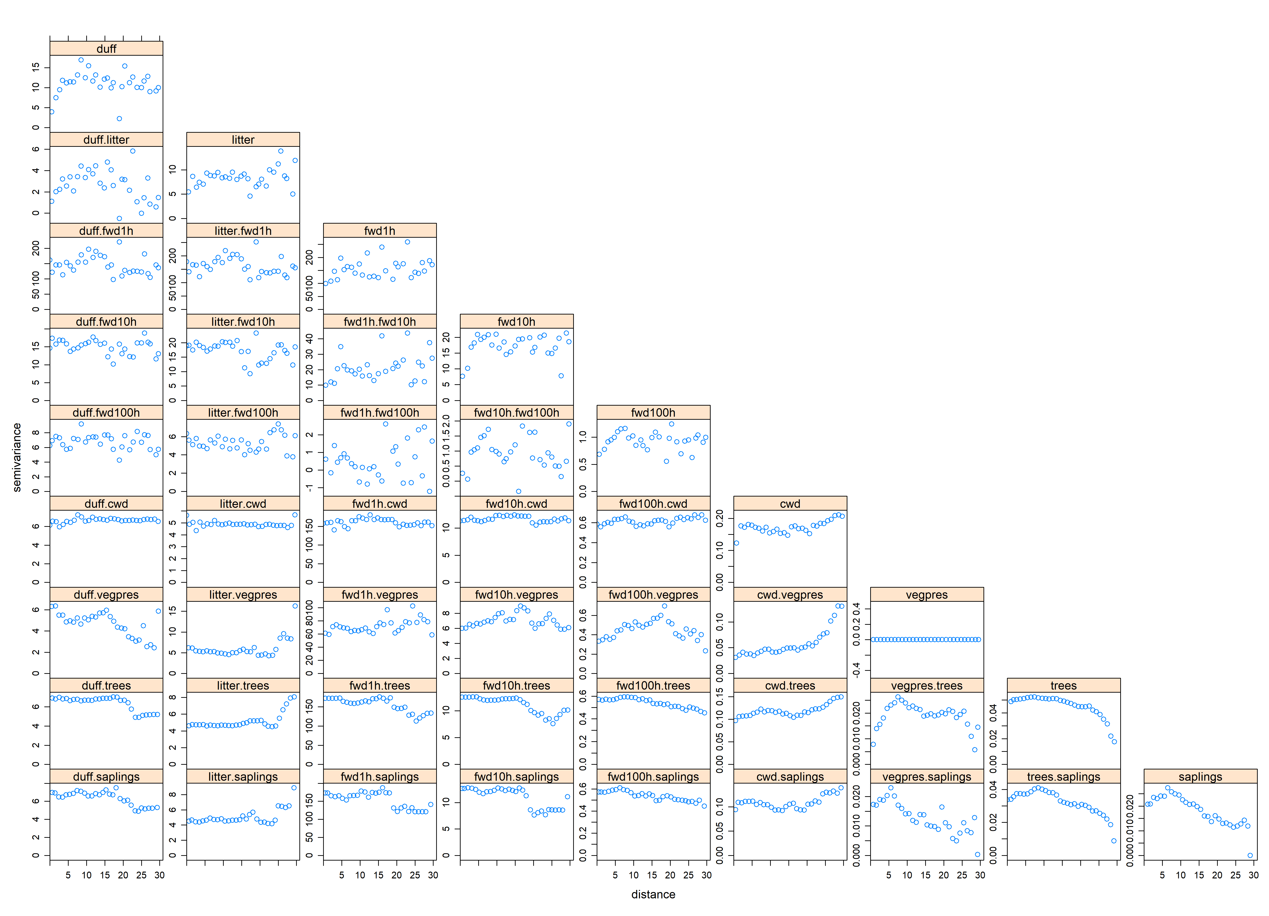
Supplementary Figure 5: Sample variograms for data from plots with high drought mortality. In each panel, the pairwise distance between observations (in meters) is on the x-axis and the semi-variance between observations at that distance (in 1-meter distance bins) is plotted on the y-axis. Increases in the semi-variance between observations as the distance between them increases are evidence of spatial autocorrelation. The variograms become noisier for distances above ~10m for which there are fewer pairs of observations. The diagonal panels show the variograms within each fuel component (spatial autocorrelation), and the off-diagonal panels show the cross-variograms between different fuel components (spatial cross-correlation). There is clear evidence of spatial autocorrelation for all fuel components except litter, for which the variogram is ambiguous, vegetation presences, and tree counts. There is noisy evidence of spatial cross correlation between 1-hour and 10-hour fine woody debris, between 10-hour and 100-hour fine woody debris, between 100-hour fine woody debris and vegetation presences, and between vegetation presences and tree counts. There is clear evidence of spatial cross correlation between duff and litter and between 10-hour fine woody debris and vegetation heights.

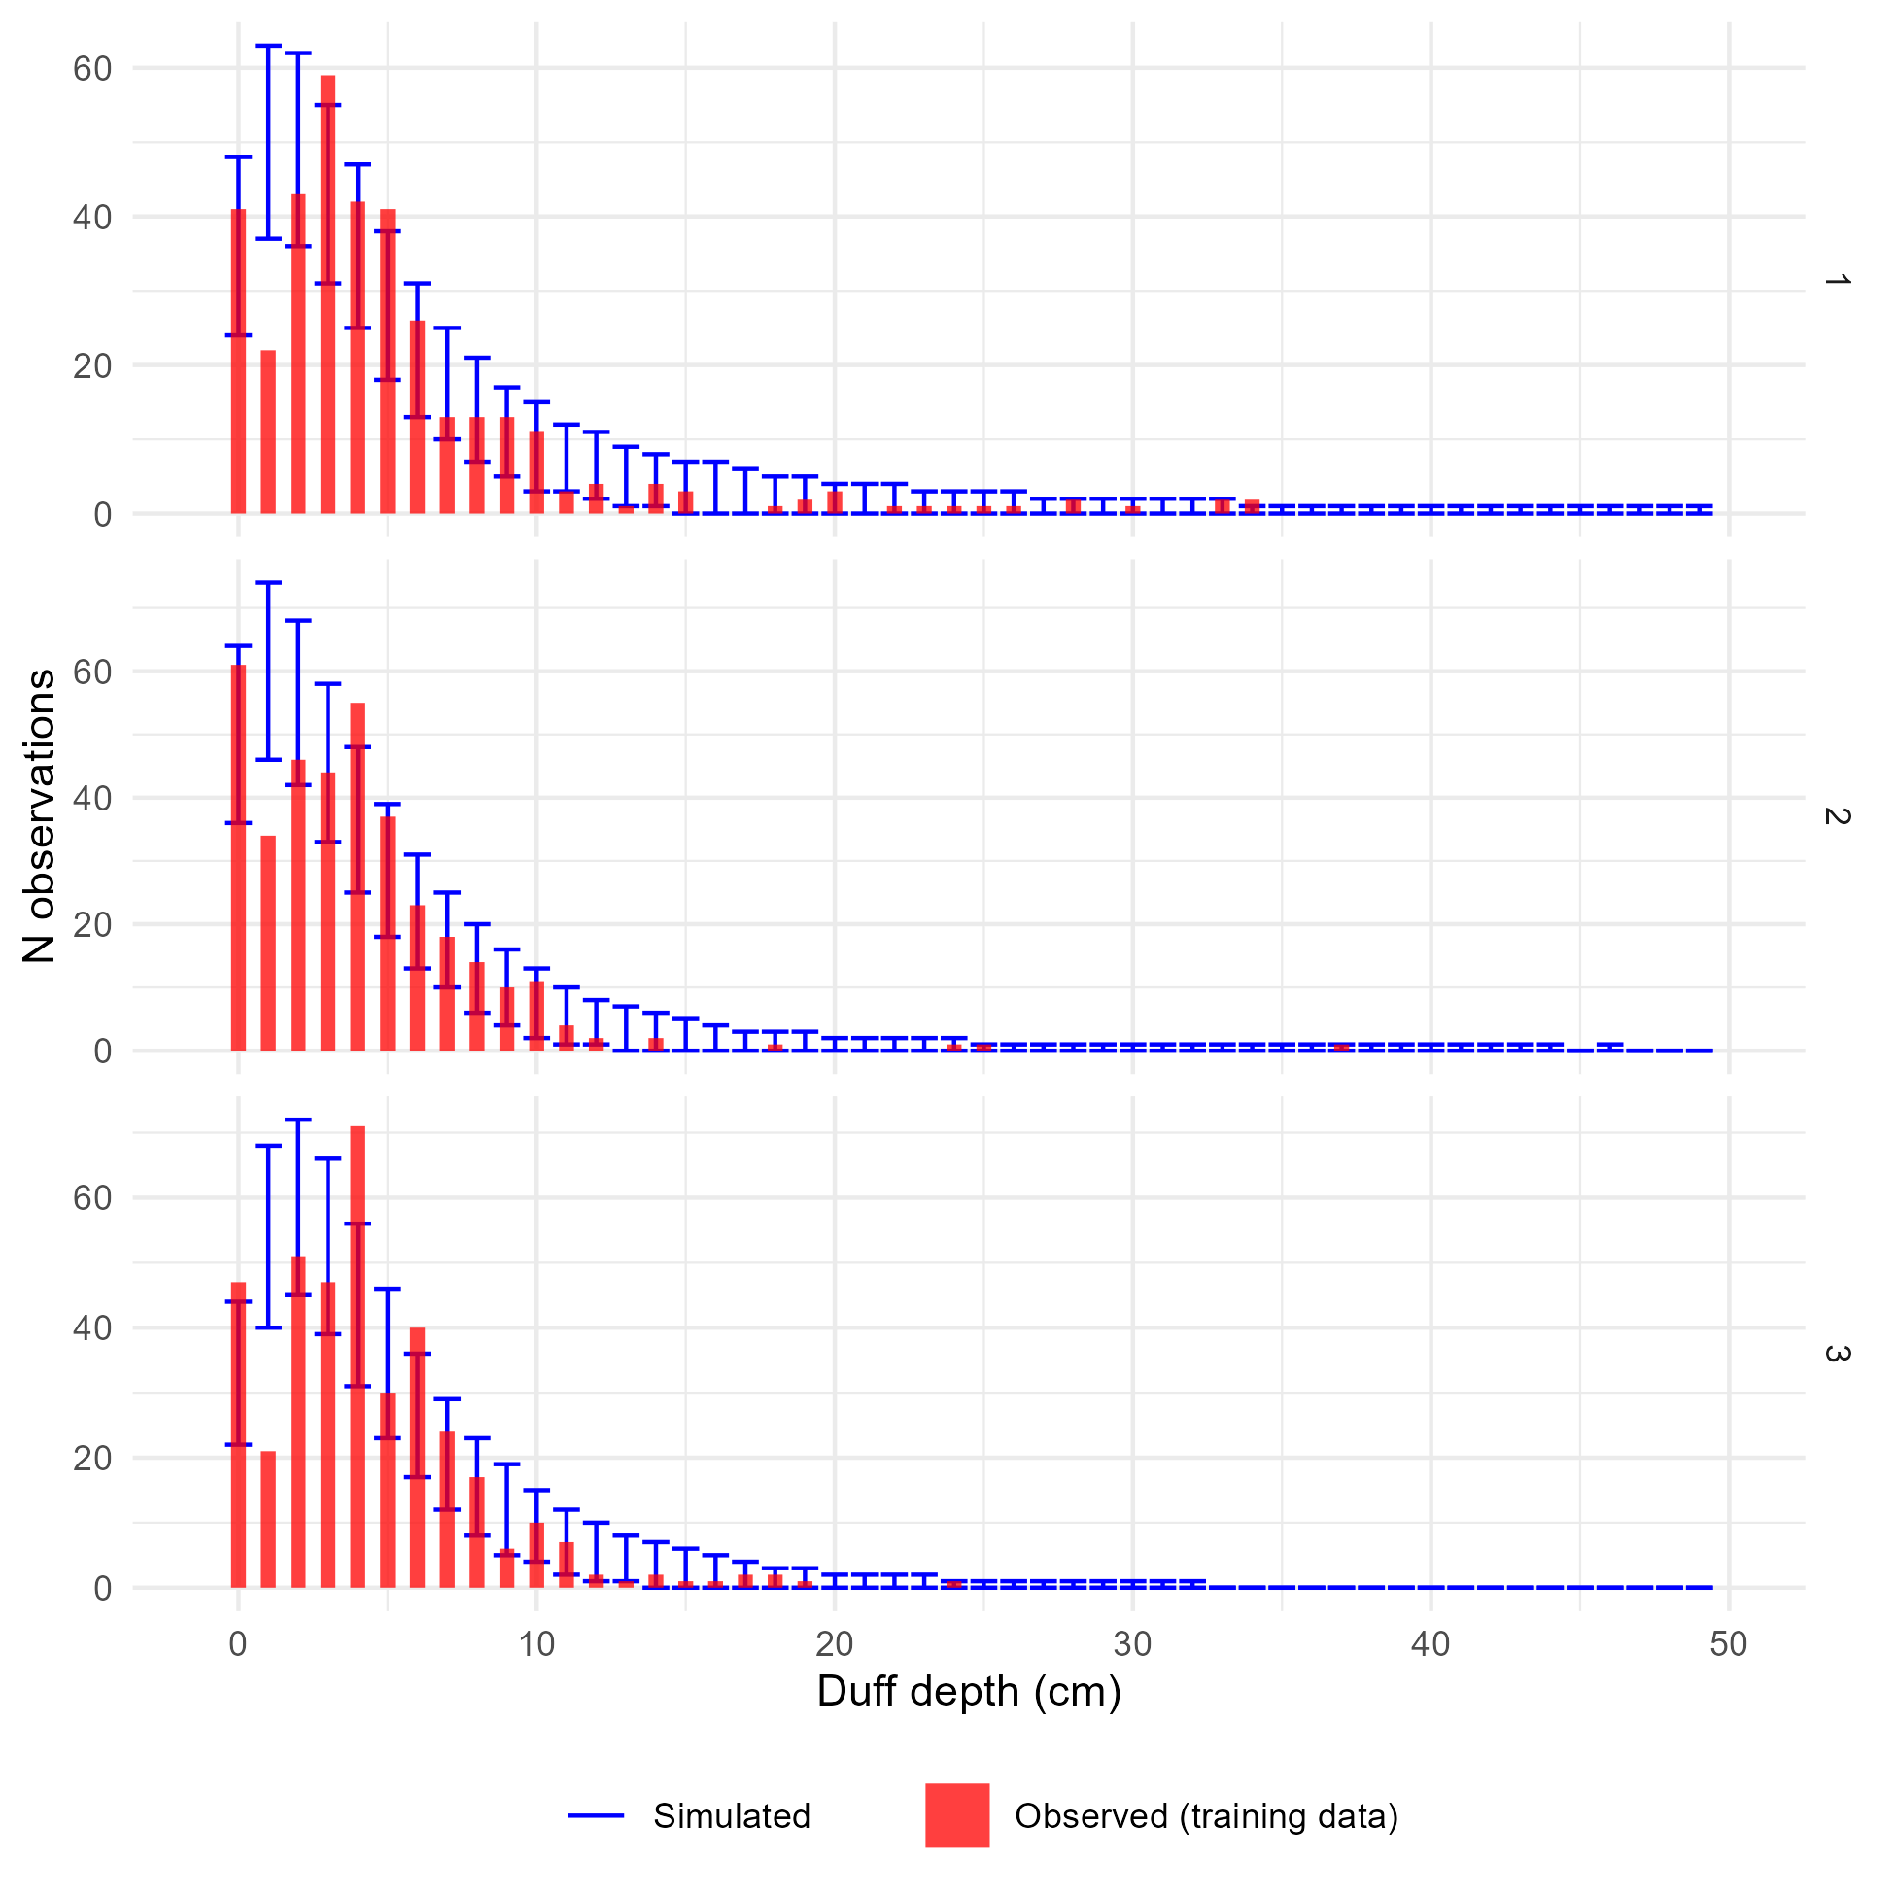
Supplementary Figure 6: Comparison of observed and simulated frequency distributions for the training data and the duff depths model. Panels show posterior predictions generated using the posterior parameter values and the training data for each of the three submodels representing low, medium, and high drought mortality (1, 2, and 3, respectively). In each panel, the x-axis shows an (observed or simulated) depth of duff and the y-axis shows the frequency of samples from a dataset of 1,107 duff depth measurements having that depth (i.e., a histogram). The observed distribution of duff depths is plotted as the red histogram. The error bars within each depth value show the 2.5th and 97.5th percentile of the frequency of simulated samples having that depth value, across each of the 4,000 posterior draws showing the variation in model-predicted frequency distributions. The observed data are generally within the range of behaviors predicted by the model, except that the model appears to underpredict the proportion of 0 cm samples, overpredict the proportion of 1 cm samples, and underpredict the proportion of 3 cm samples. The x-axis has been restricted to improve readability.

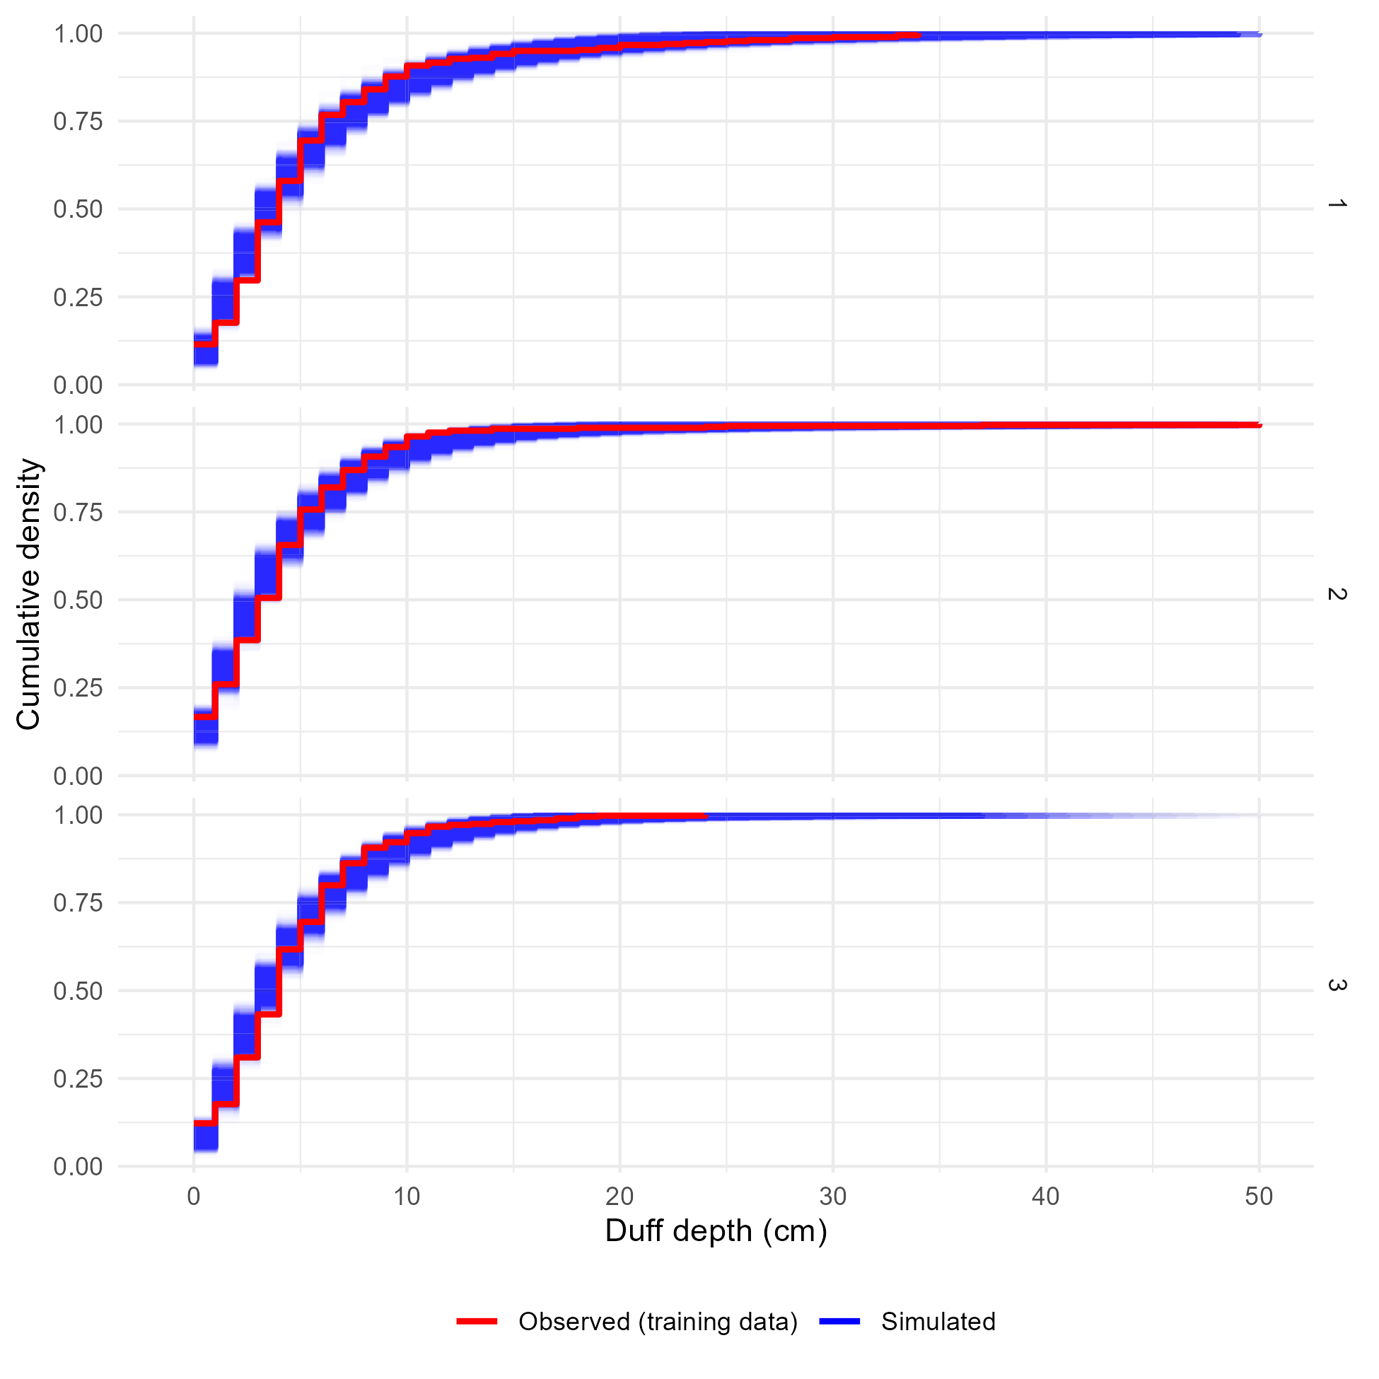
Supplementary Figure 7: Comparison of the observed and simulated cumulative density functions for the training data and the duff depths model. Panels show the cumulative density functions of the observed training data (red) and each of 4,000 simulated datasets generated using posterior parameter values and random effect realizations (blue) for each of the three sub-models corresponding to low, medium, or high levels of drought mortality. The observed cumulative density functions fall within the range of behaviors predicted by the model, indicating good agreement between the model and reality. The x-axis has been restricted for readability.

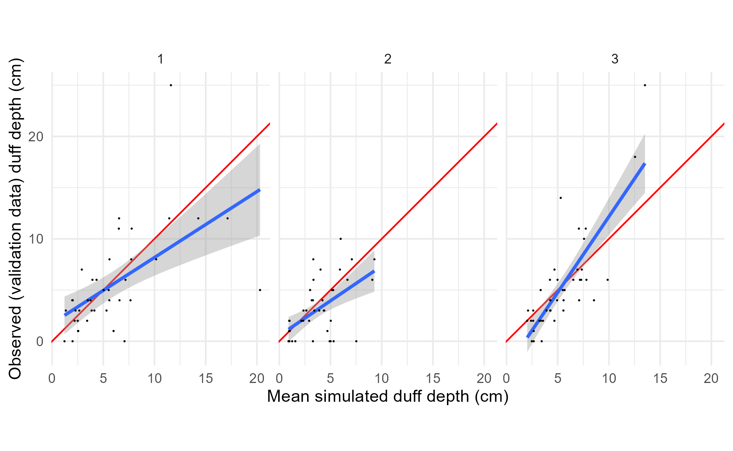
Supplementary Figure 8: Per-observation comparisons of mean predicted and observed values for the validation data and the duff depths model. Panels show posterior predictions generated using the posterior parameter values and the validation data for each of the three submodels representing low, medium, and high drought mortality (1, 2, and 3, respectively). In each panel, the posterior mean value of simulated duff depth for each observation is on the x-axis, and the observed depth for that observation on the y-axis, with points for each observation in the training dataset. Simulated data are conditional on the posterior samples of random effect realizations. A 1:1 line (representing perfect prediction) is shown in red, and a linear fit between the simulated and observed values shown in blue. The relationship between the observed and simulated data has a slope near 1, though the relationship is noisy.

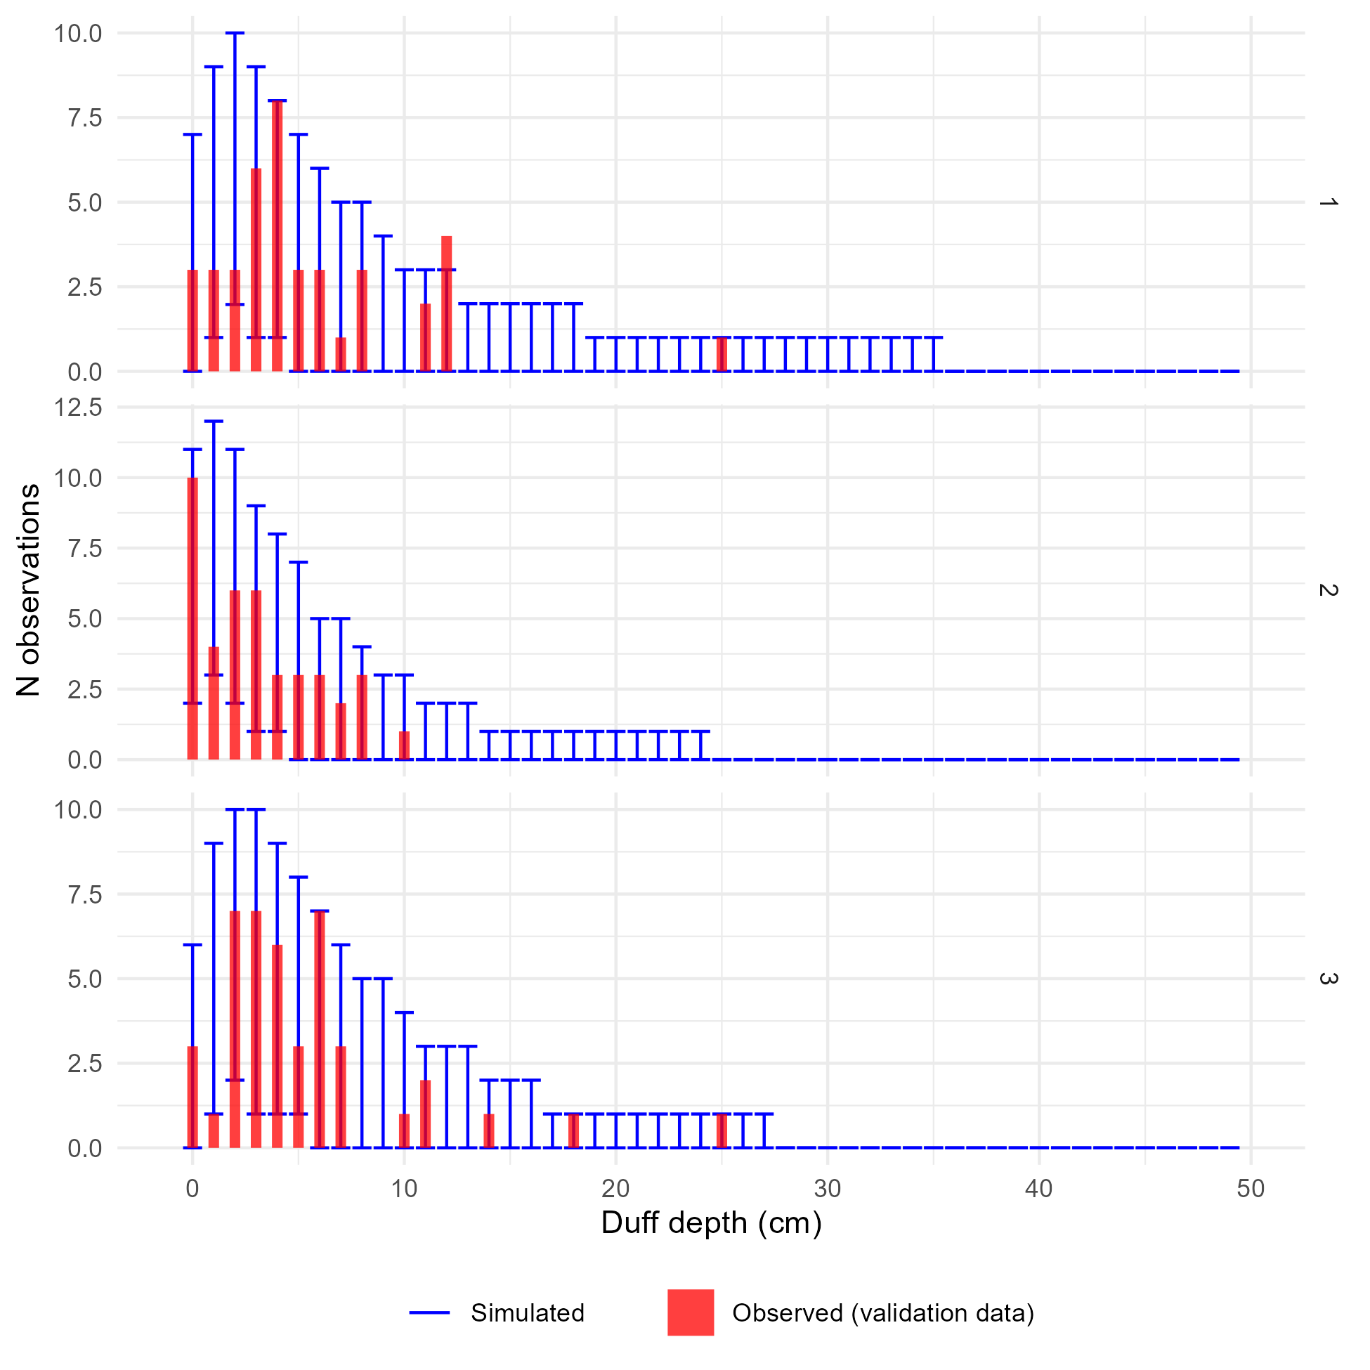
Supplementary Figure 9: Comparison of observed and simulated density distributions for the validation data and the duff depths model. Panels show posterior predictions generated using the posterior parameter values and the validation data for each of the three submodels representing low, medium, and high drought mortality (1, 2, and 3, respectively). In each panel, the x-axis shows an (observed or simulated) depth of duff and the y-axis shows the frequency of samples from a dataset of 124 duff depth measurements having that depth (i.e., a histogram). The observed distribution of duff depths is plotted as the red histogram. The error bars within each depth value show the 2.5th and 97.5th percentile of the frequency of simulated samples having that depth value, across each of the 4,000 posterior draws showing the variation in model-predicted frequency distributions. The x-axis bounds have been limited to improve readability. The observed data are generally within the range of behaviors predicted by the model, though with so few data points the simulated depth distributions are noisy resulting in wide ranges for the proportion of samples falling in each bin.

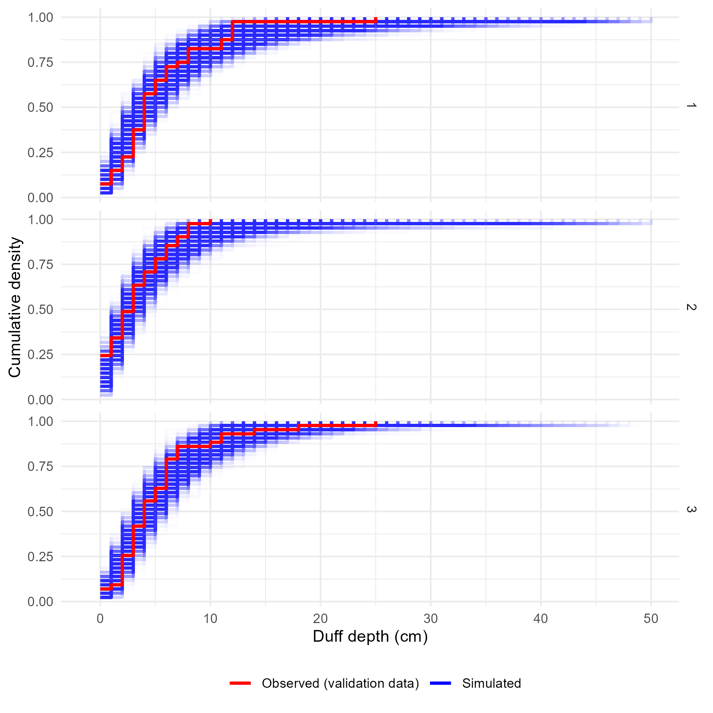
Supplementary Figure 10: Comparison of the observed and simulated cumulative density functions for the validation data and the duff depths model. Panels show the cumulative density functions of the observed validation data (red) and each of 4,000 simulated datasets generated using posterior parameter values and random effect realizations (blue) for each of the three sub-models corresponding to low, medium, or high levels of drought mortality. The x-axis bounds have been limited to improve readability. The observed cumulative density functions fall within the range of behaviors predicted by the model, indicating good agreement between the model and reality.

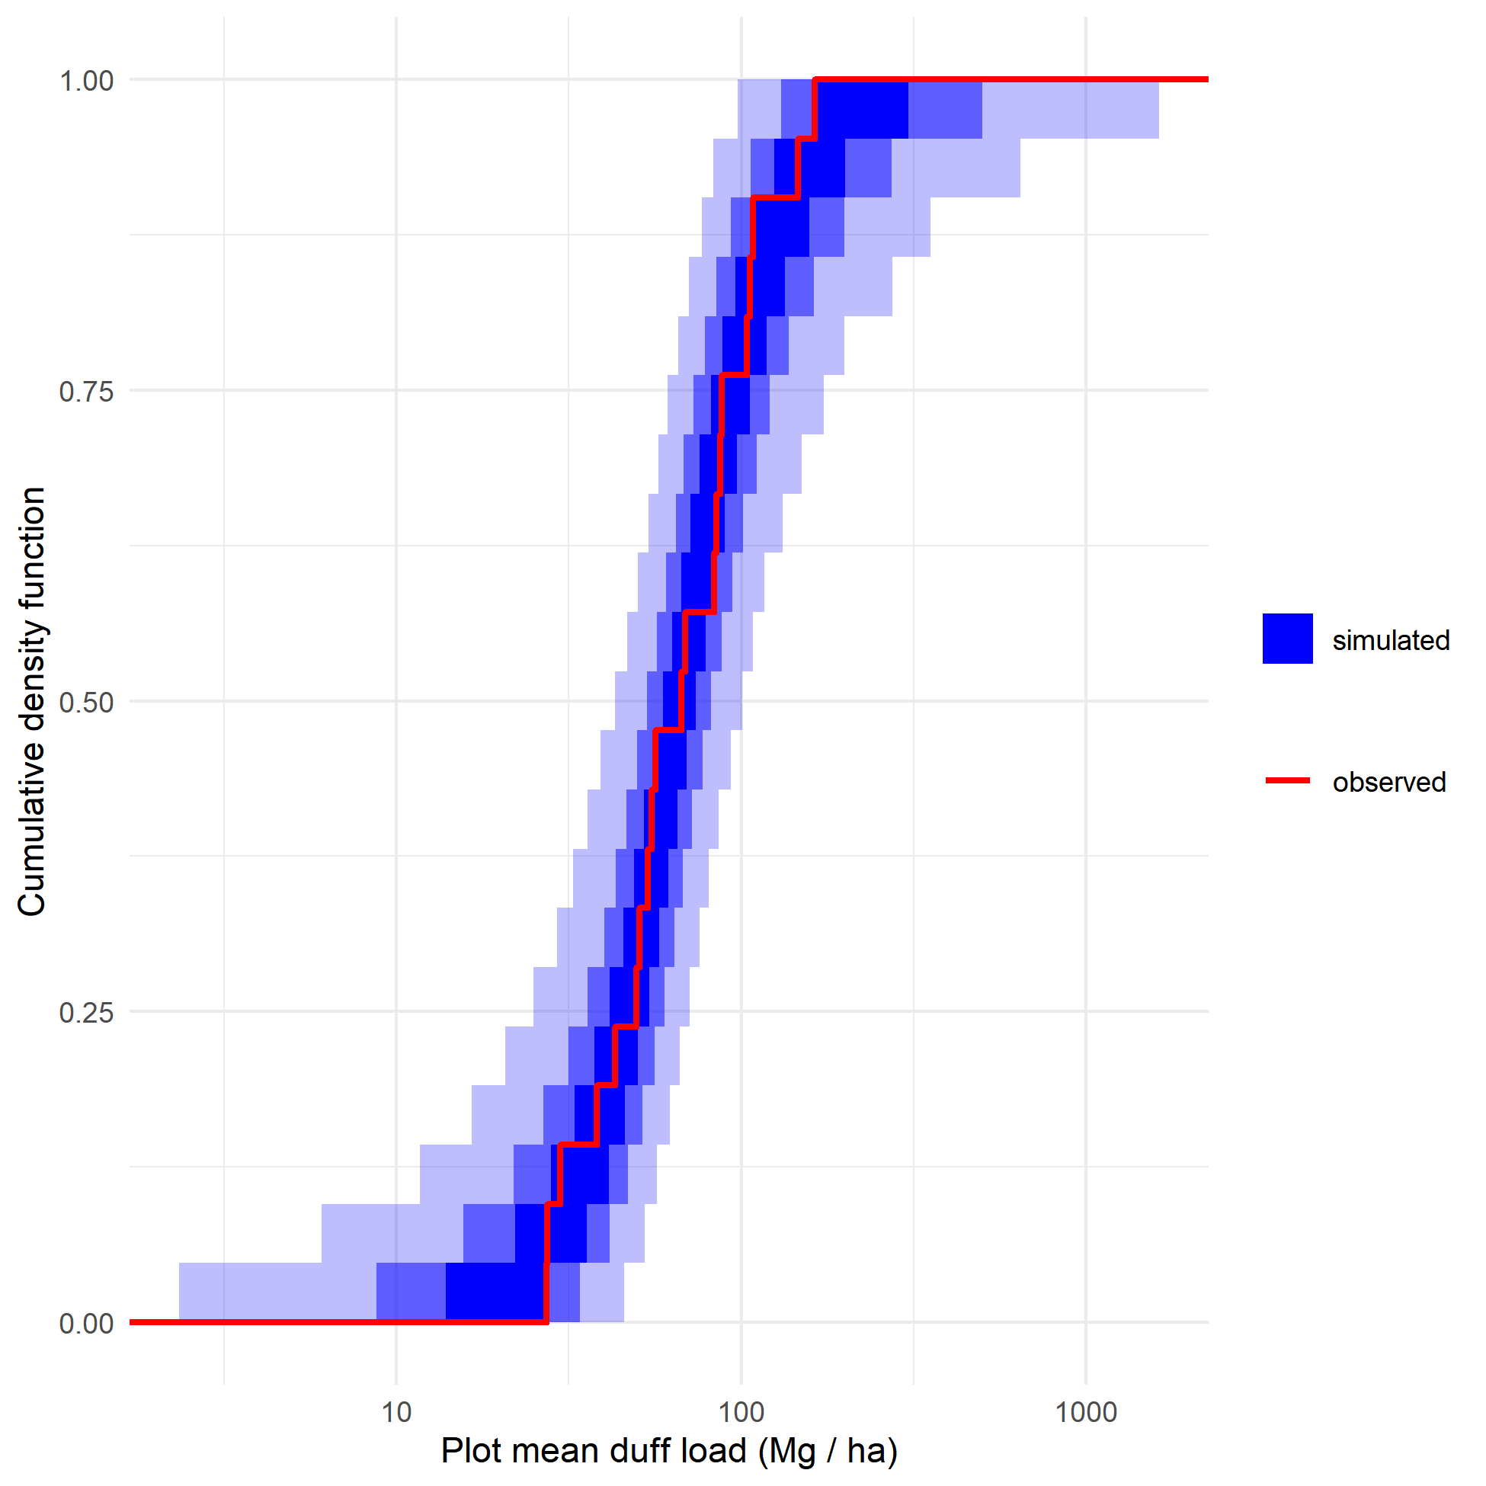
Supplementary Figure 11: Plot-level duff simulations. For each of 4,000 posterior draws, 1,107 depth samples were simulated using posterior parameter values and drawing new random effect realizations for both fine-scale (Gaussian process) and coarse-scale (normally distributed plot intercepts) random effects. The depth samples were converted to biomass estimates and averaged at the plot level, giving 21 simulated plot-level fuel loads per posterior draw. The red cumulative density function is the cumulative density function of plot-level fuel loads calculated from the observed data. The blue bands show an envelope containing 50% (darkest), 90%, and 99% (lightest) of the cumulative density functions from the simulated draws. The observed data are within the range of behaviors predicted by the model, but the model predictions do include rare outcomes (plot-level fuel loads greater than 1000 Mg/ha or less than 1 Mg/ha) which are more extreme than is ecologically plausible.
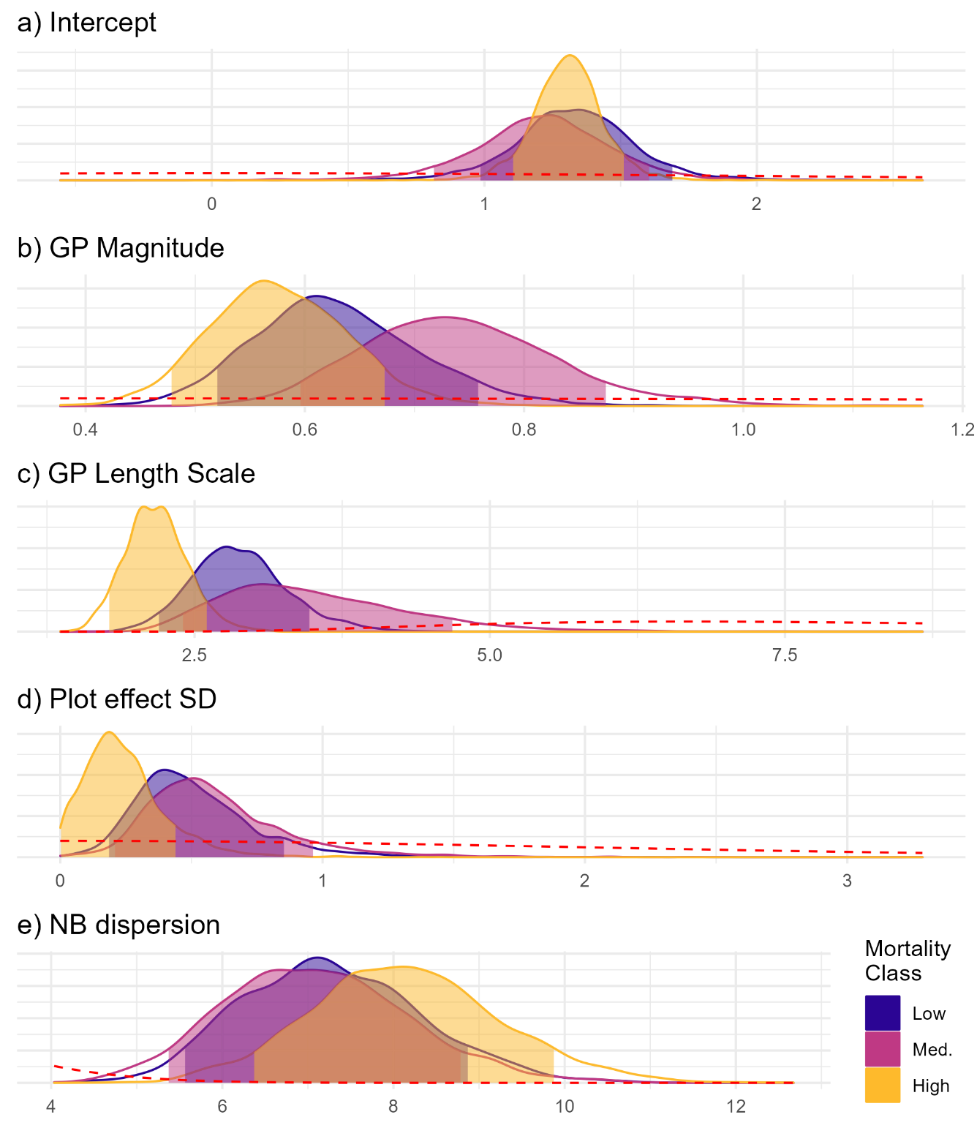
Supplementary Figure 12: Posterior probability distributions for parameters of the duff depths model. Colors indicate the group (drought mortality class). Each panel is for a model parameter, with the parameter value on the x-axis and the posterior probability density on the y-axis. The shaded portion of each posterior probability density curve shows an 89% credible interval for each parameter. The prior probability density for each parameter is shown as the red dashed lines. For all parameters, the posterior values for each group are sharply different from the relatively broad prior distribution, indicating that the posteriors are well informed by the data rather than the prior distribution for each parameter. There is extensive overlap in the posterior distribution across the drought mortality classes for all parameters, indicating that any differences in the parameters describing the pattern of duff depth across drought mortality classes are small relative to the uncertainty in parameter values.
Parameter | Low drought mortality | Medium drought mortality | High drought mortality
Intercept (β) | 1.33 (0.98, 1.69) | 1.22 (0.81, 1.61) | 1.31 (1.11, 1.51)
GP magnitude (α) | 0.62 (0.52, 0.76) | 0.74 (0.6, 0.88) | 0.57 (0.48, 0.67)
GP length scale (ν) | 2.86 (2.2, 3.48) | 3.39 (2.39, 4.7) | 2.16 (1.77, 2.61)
Plot effect SD (σ) | 0.47 (0.18, 0.86) | 0.54 (0.2, 0.97) | 0.22 (0, 0.44)
NB Dispersion (κ) | 7.22 (5.56, 8.88) | 7.05 (5.36, 8.8) | 8.1 (6.36, 9.88)
Supplementary Table 1: Posterior parameter values for duff depths model.
Posterior median values for each parameter are given alongside an 89% credible interval in parentheses.
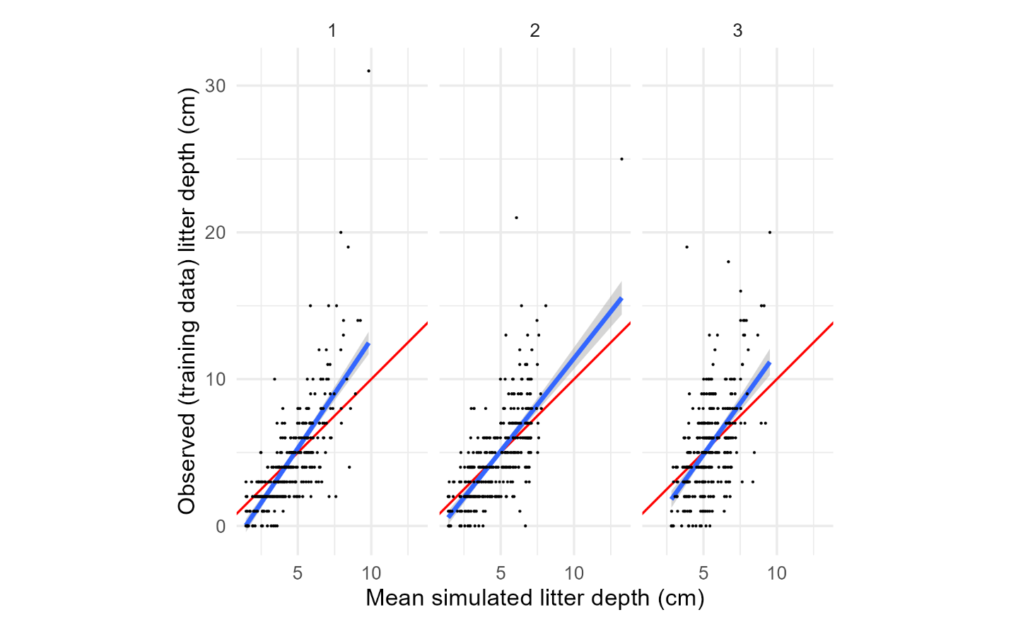
Supplementary Figure 13: Per-observation comparisons of mean predicted and observed values for the training data and the litter depths model. Panels show posterior predictions generated using the posterior parameter values and the training data for each of the three submodels representing low, medium, and high drought mortality (1, 2, and 3, respectively). In each panel, the posterior mean value of simulated litter depth for each observation is on the x-axis, and the observed depth for that observation on the y-axis, with points for each observation in the training dataset. Simulated data are conditional on the posterior samples of random effect realizations. A 1:1 line (representing perfect prediction) is shown in red, and a linear fit between the simulated and observed values shown in blue. There is a generally good but noisy fit between the simulated and observed data, though the model tends to underpredict for observed depths above ~5 cm and overpredict for observed depths below ~5 cm.

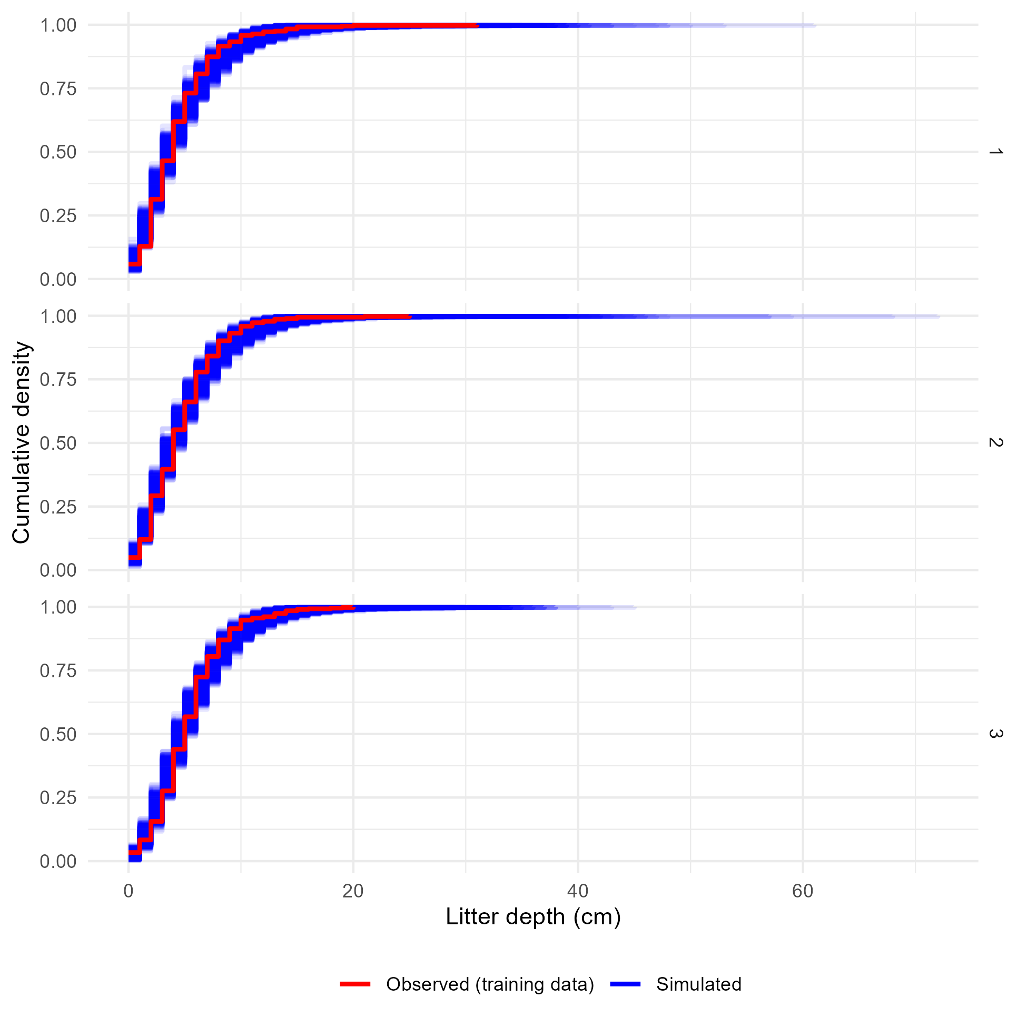
Supplementary Figure 14: Comparison of the observed and simulated cumulative density functions for the training data and the litter depths model. Panels show the cumulative density functions of the observed training data (red) and each of 4,000 simulated datasets generated using posterior parameter values and random effect realizations (blue) for each of the three sub-models corresponding to low, medium, or high levels of drought mortality. The observed cumulative density functions fall within the range of behaviors predicted by the model, indicating good agreement between the model and reality.

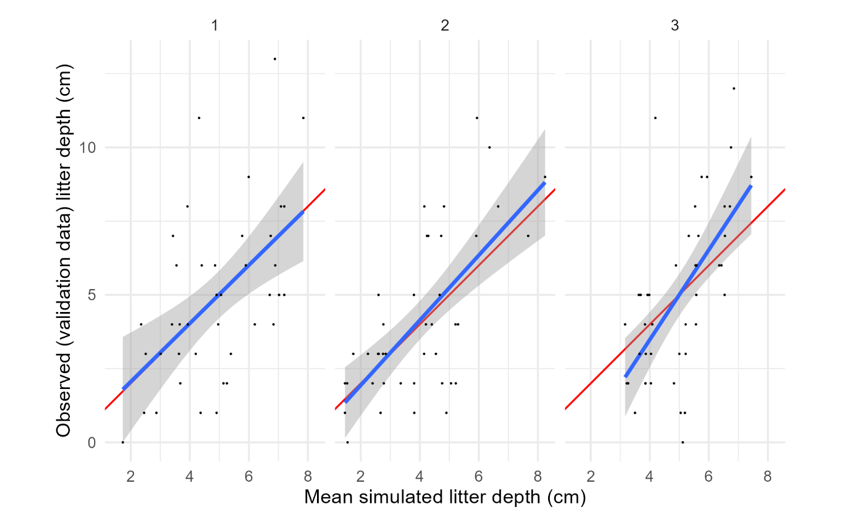
Supplementary Figure 15: Per-observation comparisons of mean predicted and observed values for the validation data and the litter depths model. Panels show posterior predictions generated using the posterior parameter values and the validation data for each of the three submodels representing low, medium, and high drought mortality (1, 2, and 3, respectively). In each panel, the posterior mean value of simulated litter depth for each observation is on the x-axis, and the observed depth for that observation on the y-axis, with points for each observation in the training dataset. Simulated data are conditional on the posterior samples of random effect realizations. A 1:1 line (representing perfect prediction) is shown in red, and a linear fit between the simulated and observed values shown in blue. There is a generally good but noisy fit between the simulated and observed data, with some tendency to underpredict for high observed depths and overpredict for low observed depths.

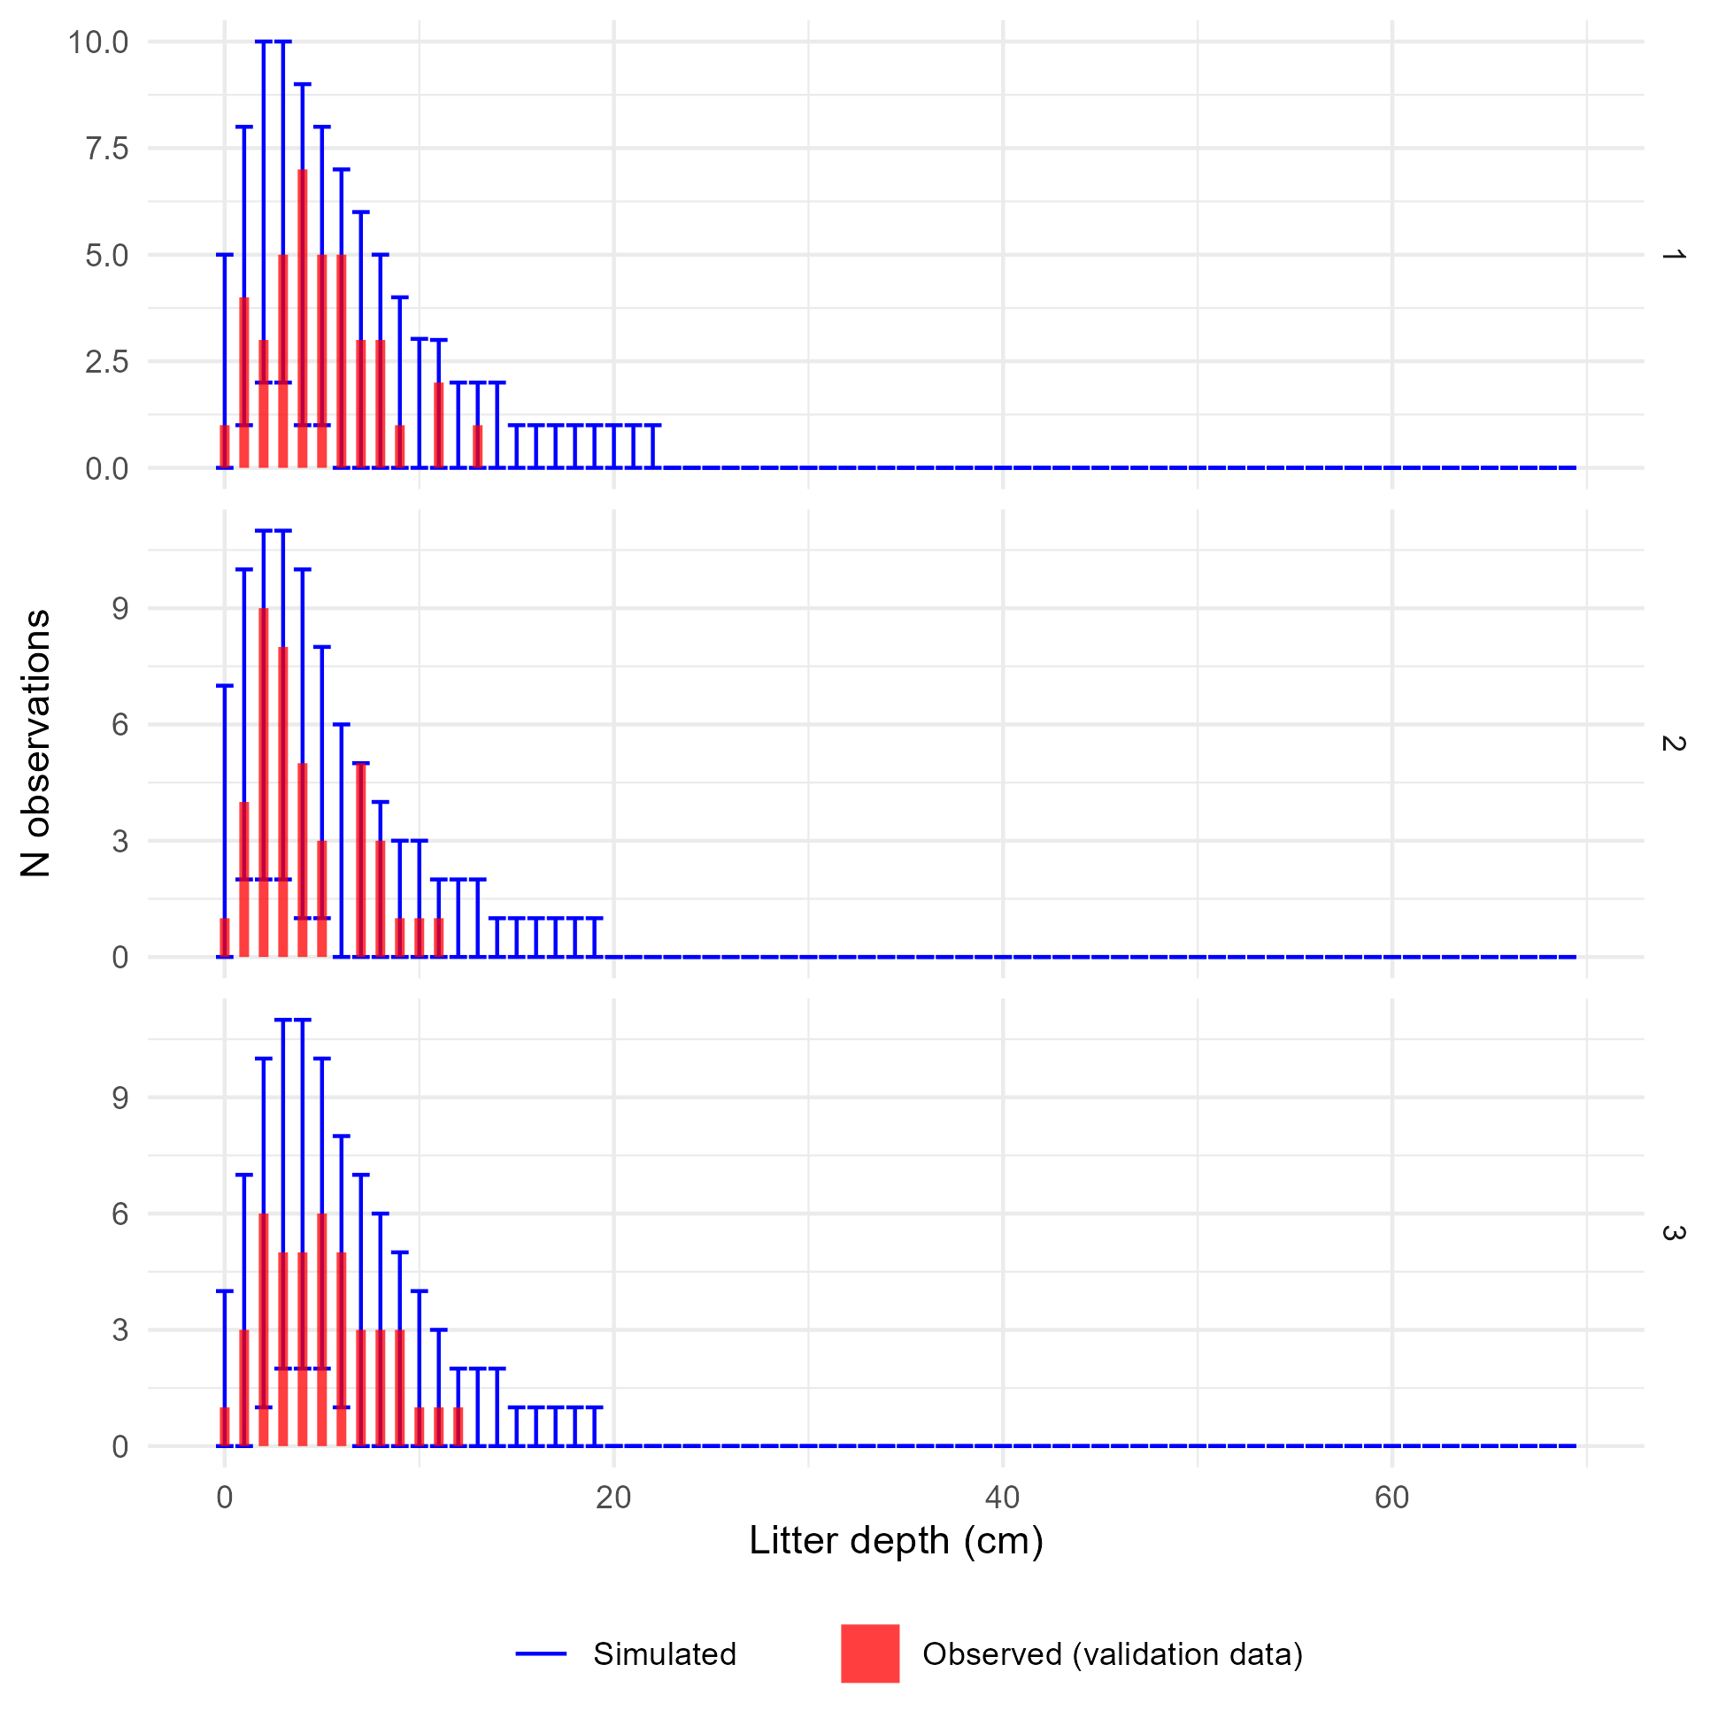
Supplementary Figure 16: Comparison of observed and simulated density distributions for the validation data and the litter depths model. Panels show posterior predictions generated using the posterior parameter values and the validation data for each of the three submodels representing low, medium, and high drought mortality (1, 2, and 3, respectively). In each panel, the x-axis shows an (observed or simulated) depth of litter and the y-axis shows the frequency of samples from a dataset of 124 litter depth measurements having that depth (i.e., a histogram). The observed distribution of litter depths is plotted as the red histogram. The error bars within each depth value show the 2.5th and 97.5th percentile of the frequency of simulated samples having that depth value, across each of the 4,000 posterior draws showing the variation in model-predicted frequency distributions. The observed data are generally within the range of behaviors predicted by the model, though with so few data points the simulated depth distributions are noisy resulting in wide ranges for the proportion of samples falling in each bin.
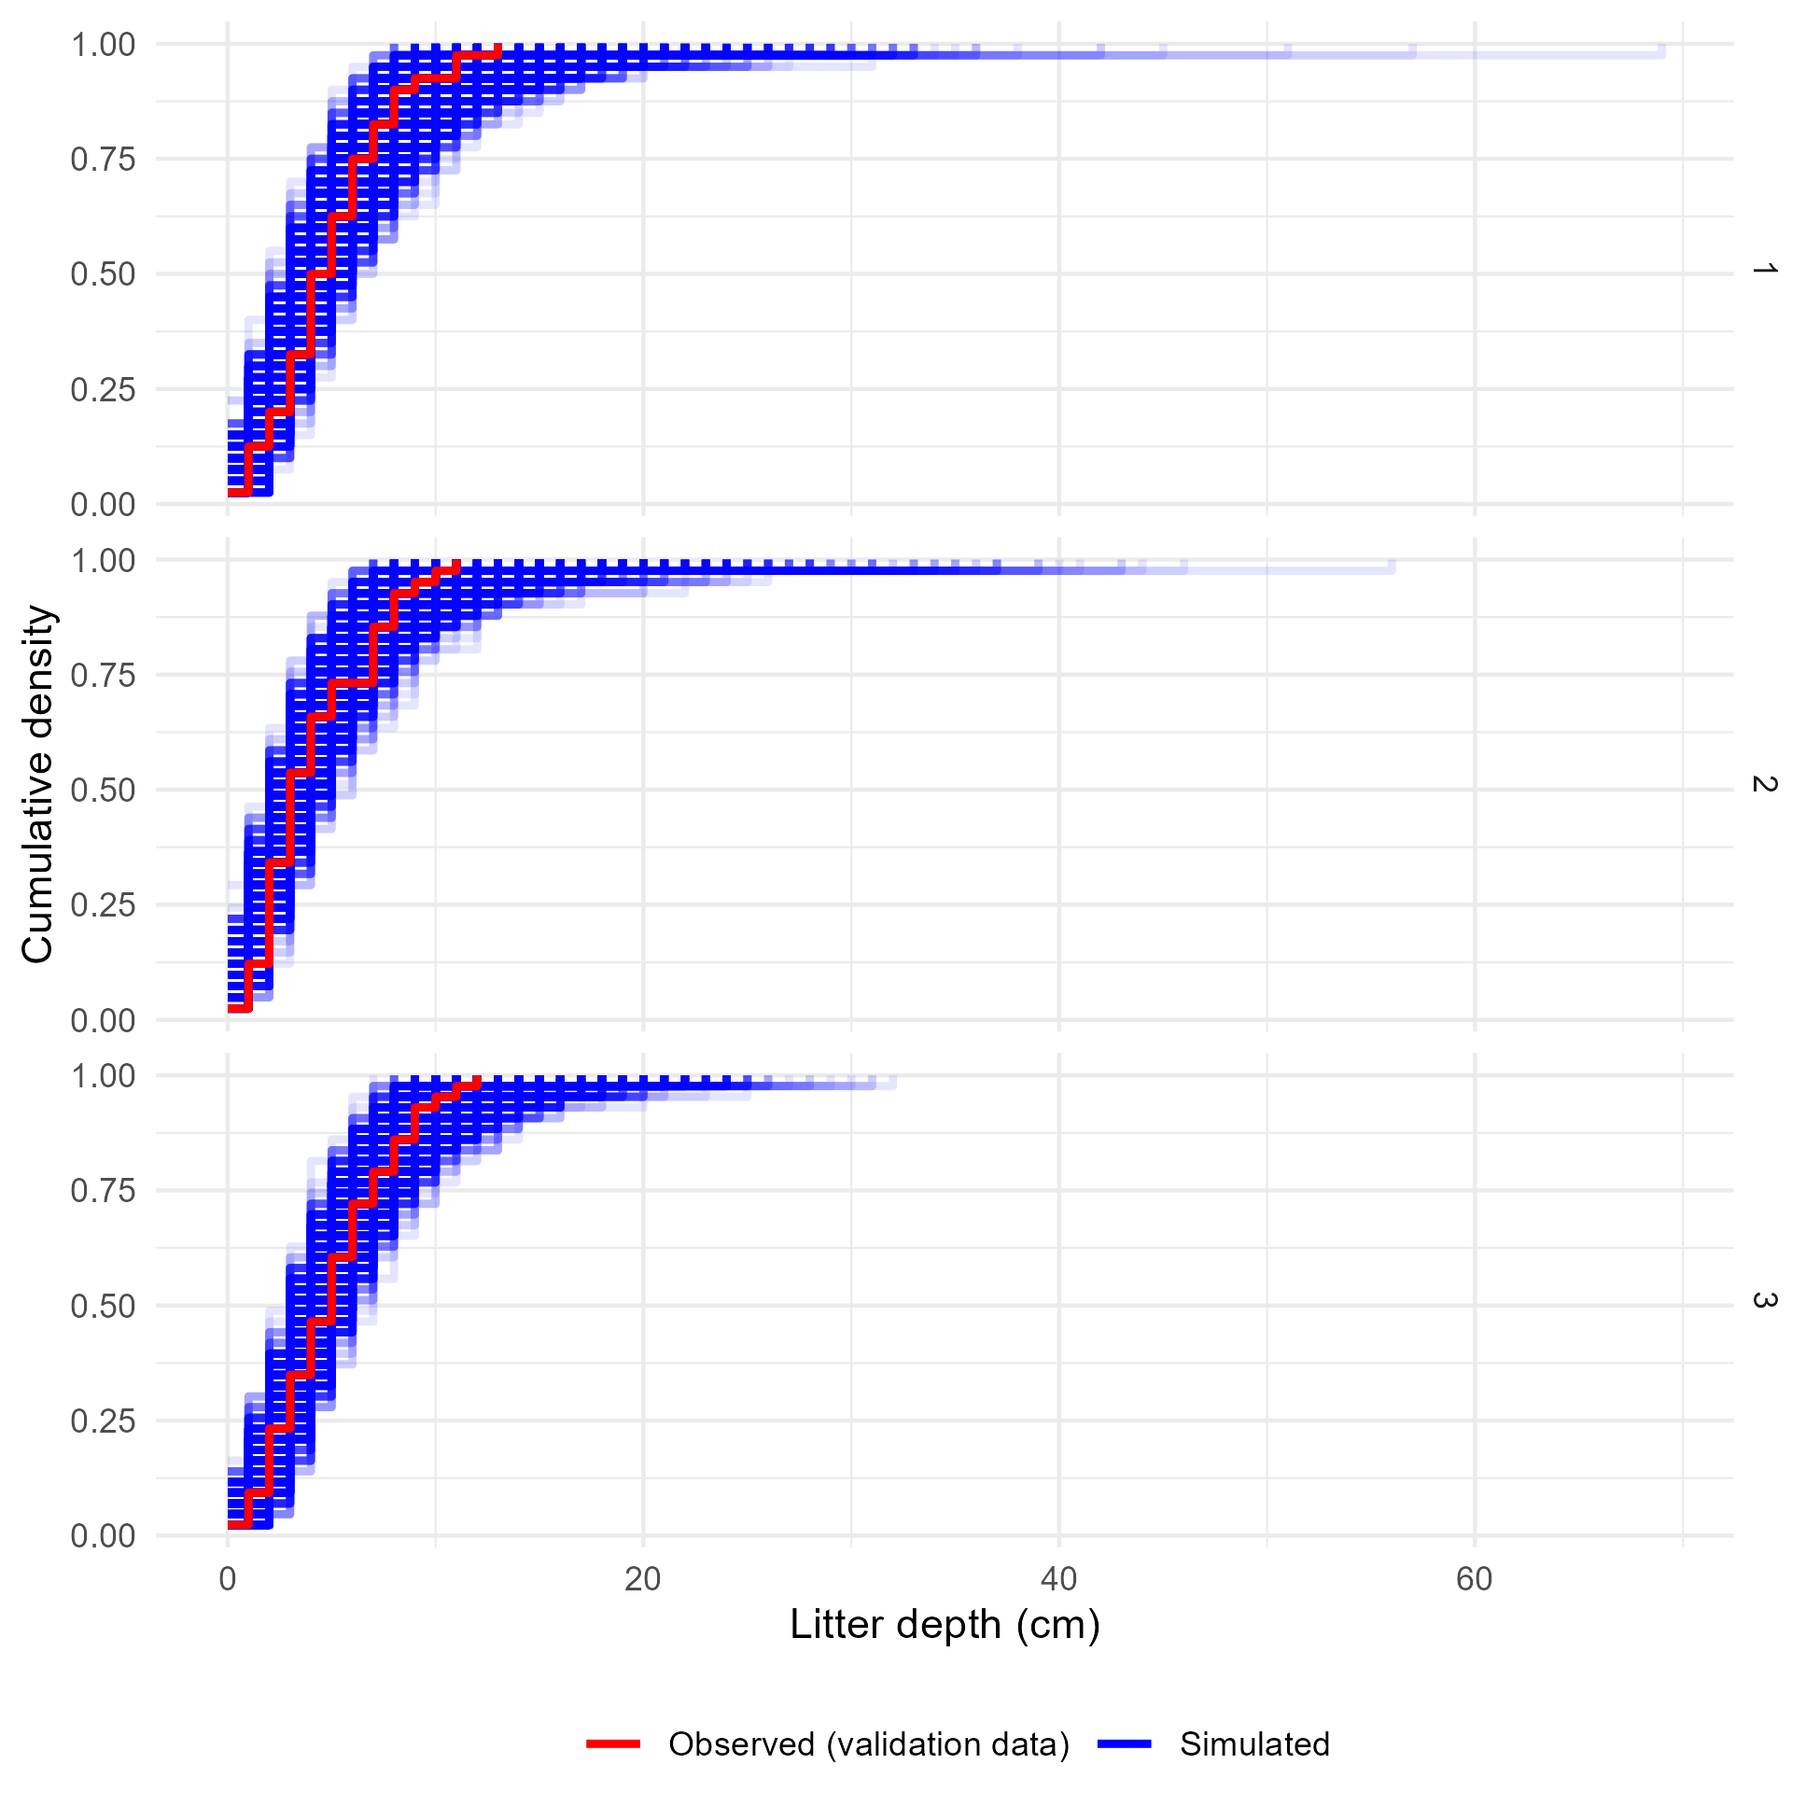
Supplementary Figure 17: Comparison of the observed and simulated cumulative density functions for the validation data and the litter depths model. Panels show the cumulative density functions of the observed validation data (red) and each of 4,000 simulated datasets generated using posterior parameter values and random effect realizations (blue) for each of the three sub-models corresponding to low, medium, or high levels of drought mortality. The observed cumulative density functions fall within the range of behaviors predicted by the model, indicating good agreement between the model and reality.

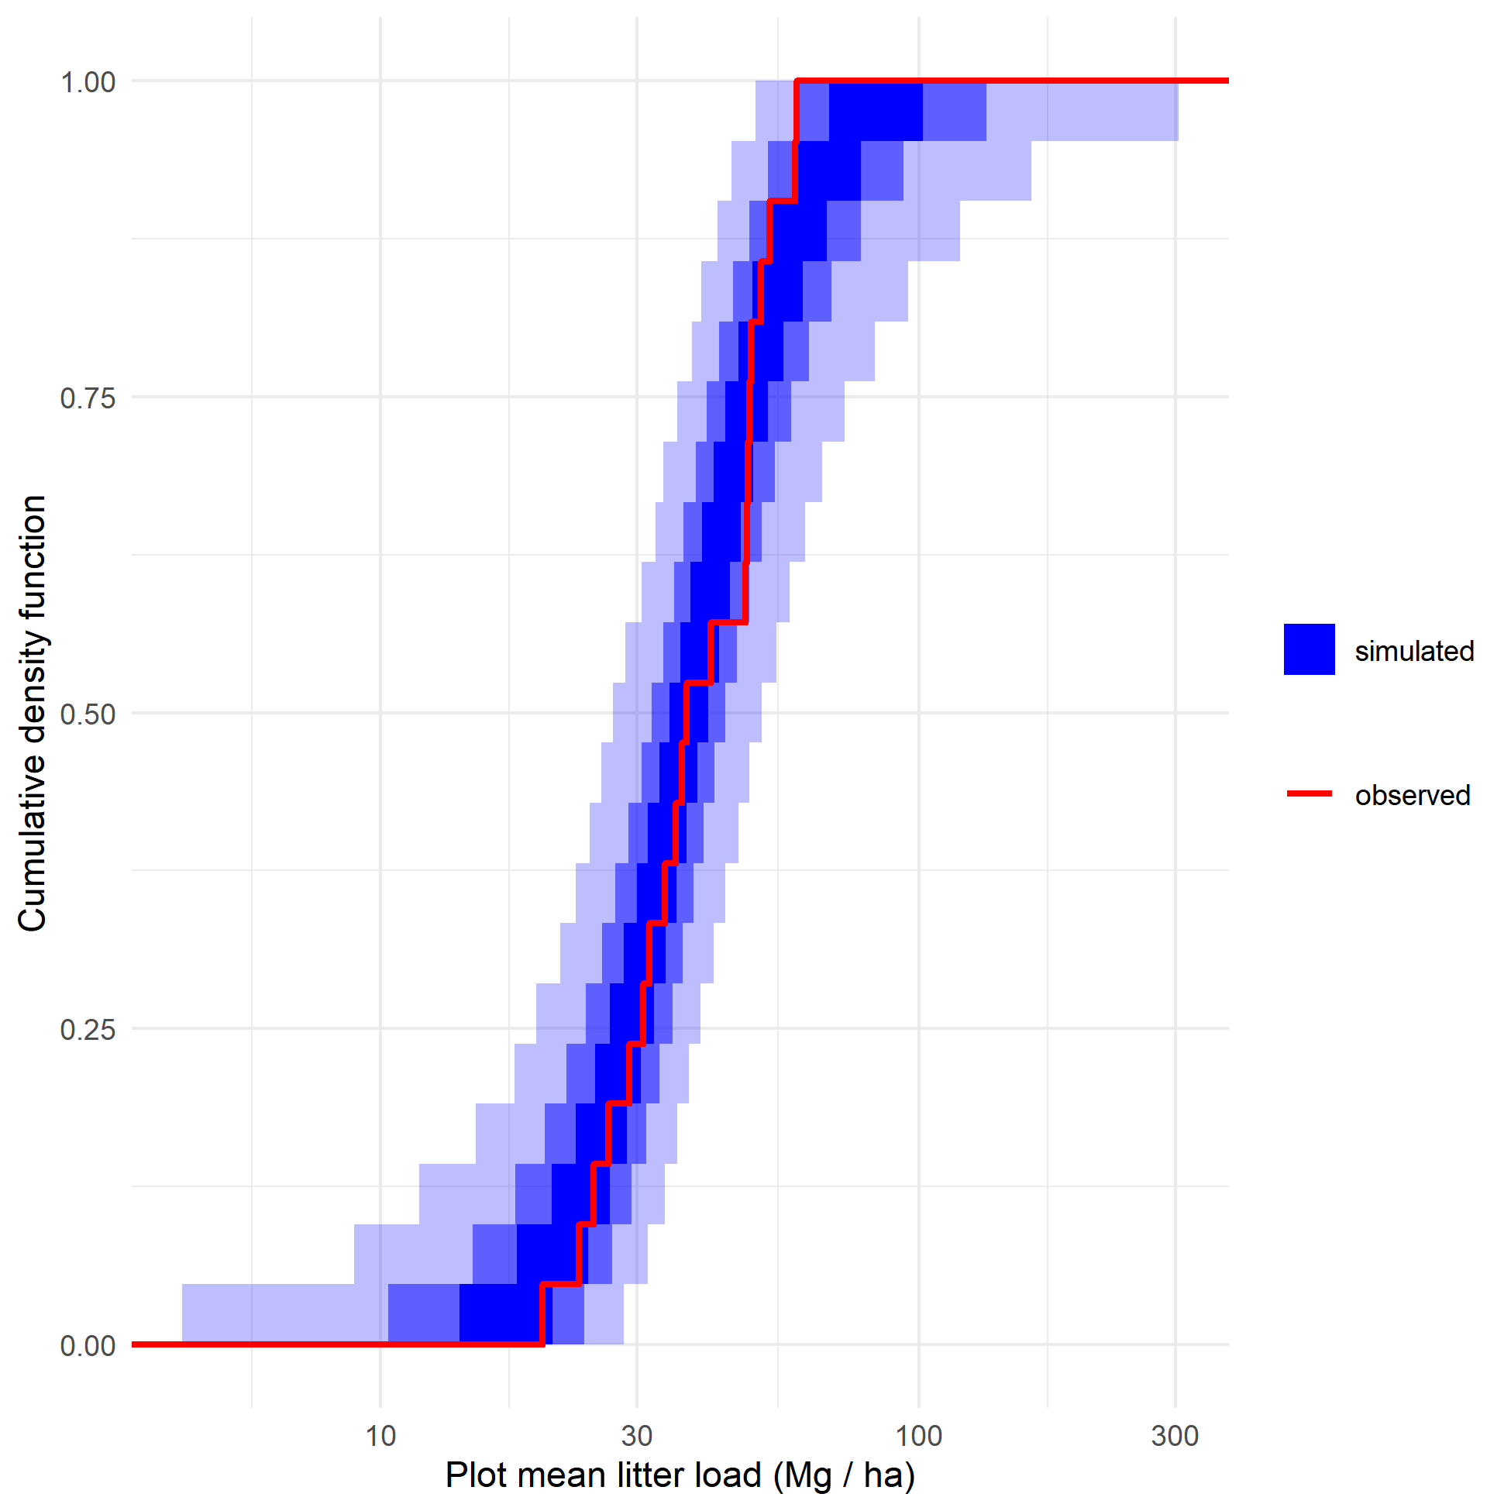
Supplementary Figure 18: Plot-level litter simulations. For each of 4,000 posterior draws, 1,107 depth samples were simulated using posterior parameter values and drawing new random effect realizations for both fine-scale (Gaussian process) and coarse-scale (normally distributed plot intercepts) random effects. The depth samples were converted to biomass estimates and averaged at the plot level, giving 21 simulated plot-level fuel loads per posterior draw. The red cumulative density function is the cumulative density function of plot-level fuel loads calculated from the observed data. The blue bands show an envelope containing 50% (darkest), 90%, and 99% (lightest) of the cumulative density functions from the simulated draws. The observed data are within the range of behaviors predicted by the model, but the highest observed plot-level fuel loads are lower than the upper quantiles of most simulated fuel loads (top of figure).

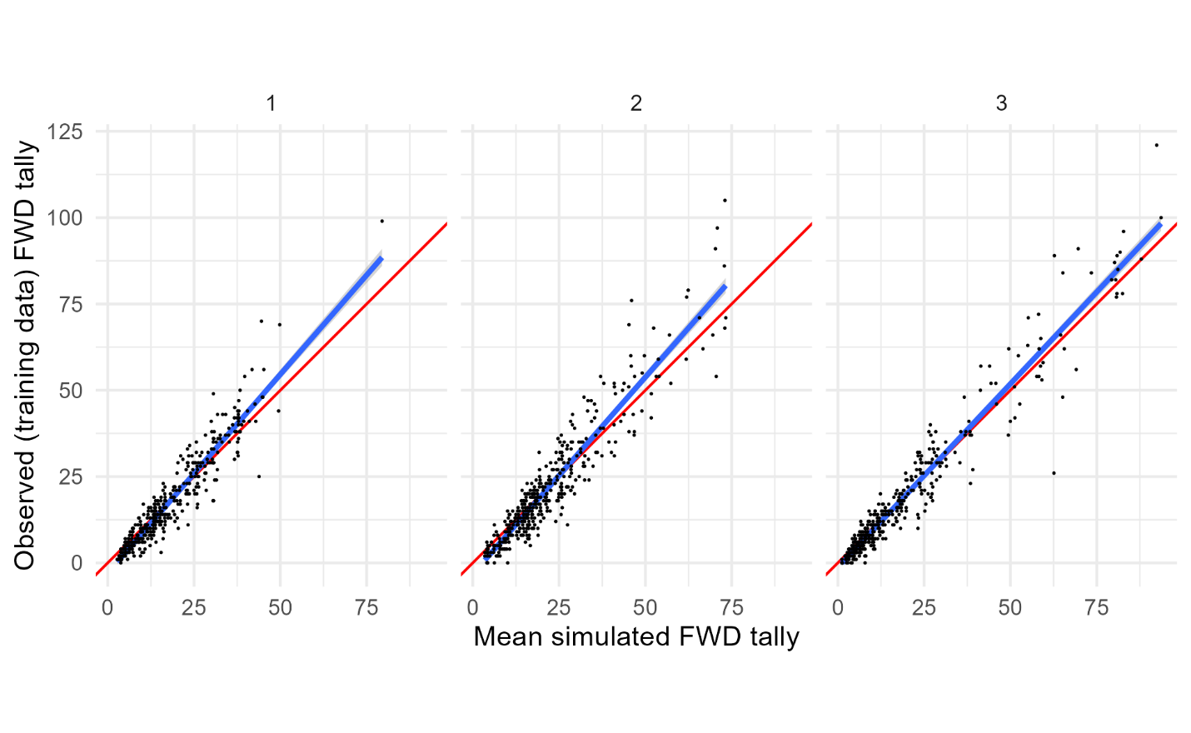
Supplementary Figure 19: Per-observation comparisons of mean predicted and observed values for the training data and the fine woody debris tallies model. Panels show posterior predictions generated using the posterior parameter values and the training data for each of the three submodels representing low, medium, and high drought mortality (1, 2, and 3, respectively). In each panel, the posterior mean value of simulated fine woody debris tally for each observation is on the x-axis, and the observed tally for that observation on the y-axis, with points for each observation in the training dataset. Simulated data are conditional on the posterior samples of random effect realizations. A 1:1 line (representing perfect prediction) is shown in red, and a linear fit between the simulated and observed values shown in blue. There is a good fit between predicted and observed values.

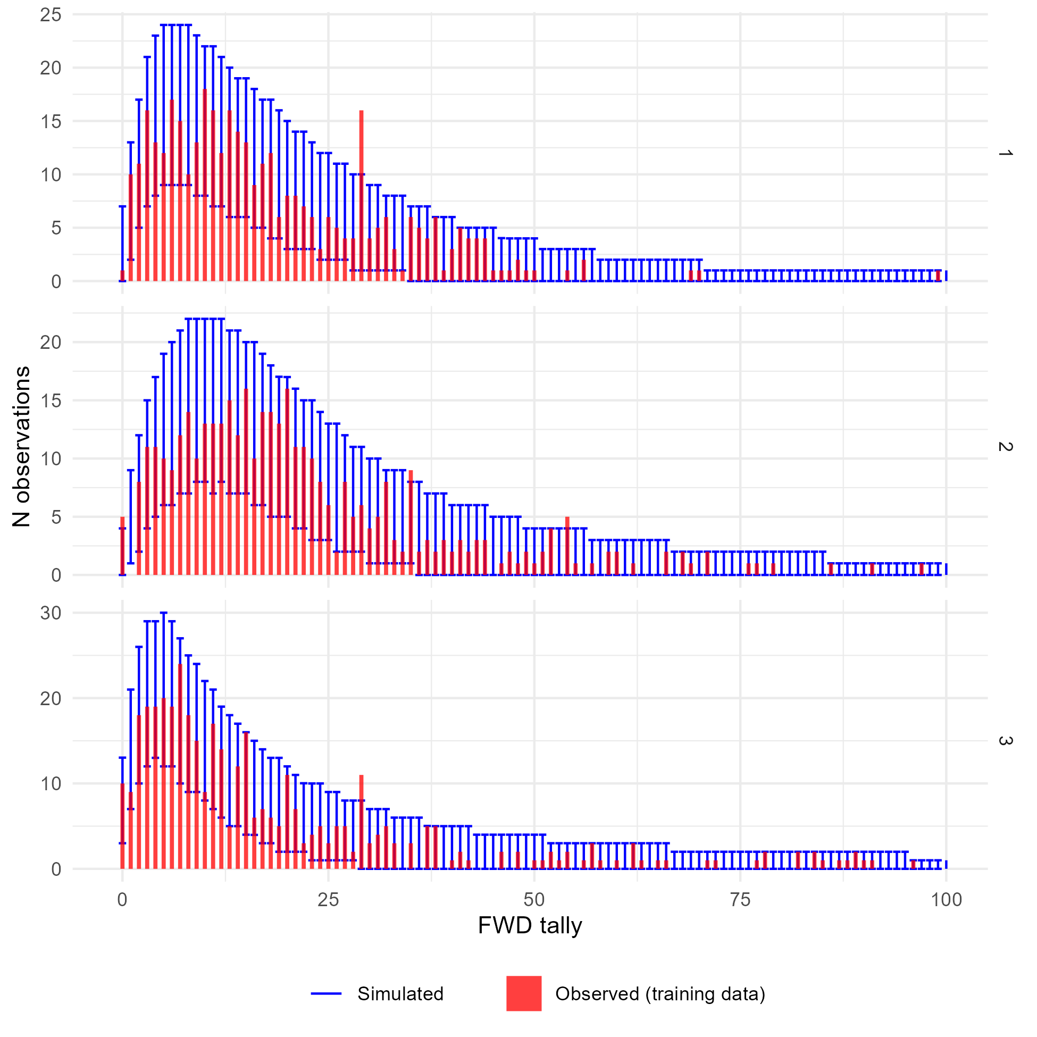
Supplementary Figure 20: Comparison of observed and simulated frequency distributions for the training data and the fine woody debris tallies model. Panels show posterior predictions generated using the posterior parameter values and the training data for each of the three submodels representing low, medium, and high drought mortality (1, 2, and 3, respectively). In each panel, the x-axis shows an (observed or simulated) tally of fine woody debris and the y-axis shows the frequency of samples from a dataset of 1,183 one meter subtransects having that tally (i.e., a histogram). The observed distribution of FWD tallies is plotted as the red histogram. The error bars within each tally value show the 2.5th and 97.5th percentile of the frequency of simulated samples having that tally value, across each of the 4,000 posterior draws showing the variation in model-predicted frequency distributions. The x-axis bounds have been limited to improve readability. The observed data are generally within the range of behaviors predicted by the model. The x-axis has been restricted for readability.

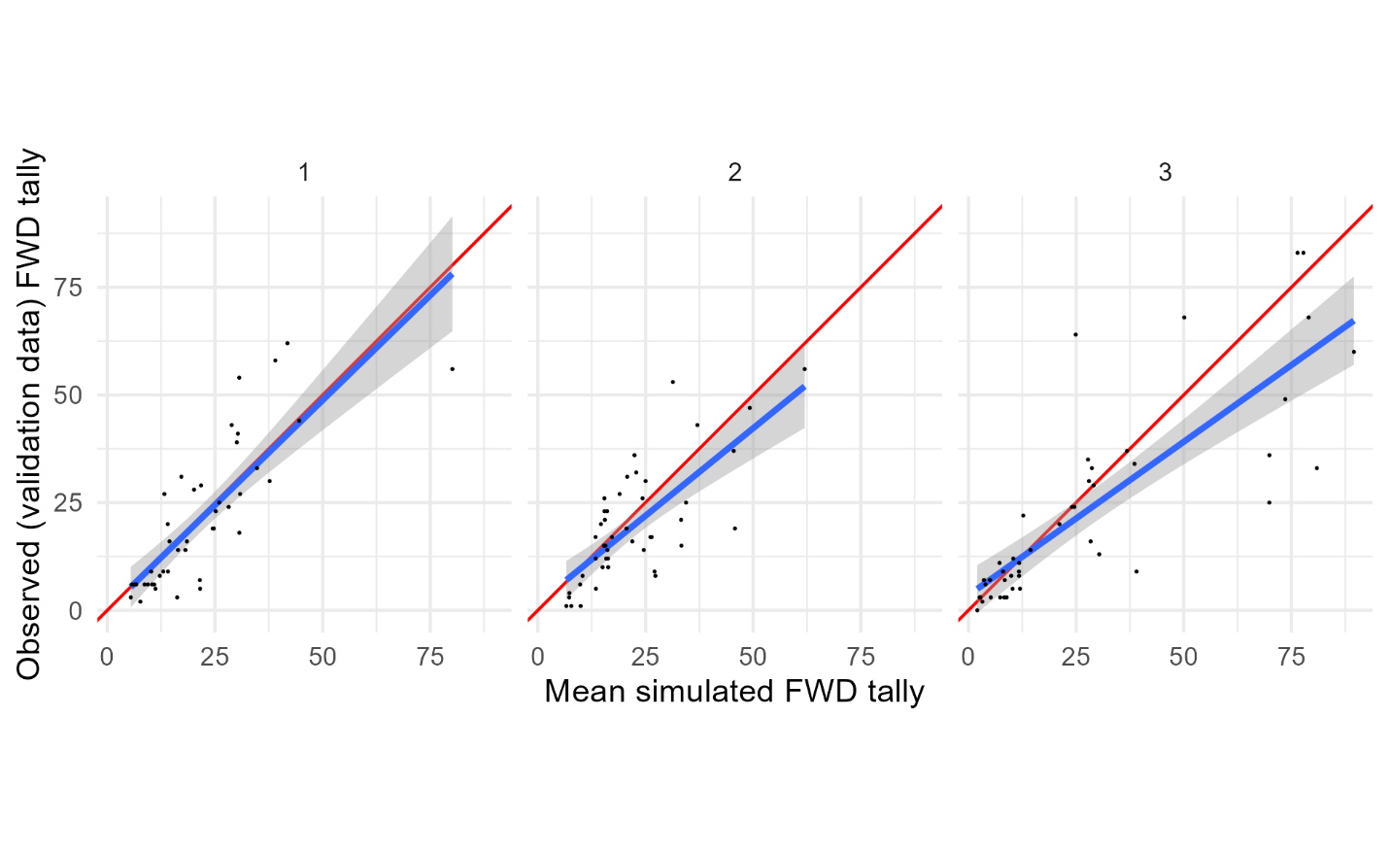
Supplementary Figure 21: Per-observation comparisons of mean predicted and observed values for the validation data and the fine woody debris tallies model. Panels show posterior predictions generated using the posterior parameter values and the validation data for each of the three submodels representing low, medium, and high drought mortality (1, 2, and 3, respectively). In each panel, the posterior mean value of simulated fine woody debris tally for each observation is on the x-axis, and the observed tally for that observation on the y-axis, with points for each observation in the validation dataset. Simulated data are conditional on the posterior samples of random effect realizations. A 1:1 line (representing perfect prediction) is shown in red, and a linear fit between the simulated and observed values shown in blue. The fit between observed and predicted values is noisy, and for sub-models 2 and 3 (medium and high drought mortality) the model tends to under-predict tallies above ~25.

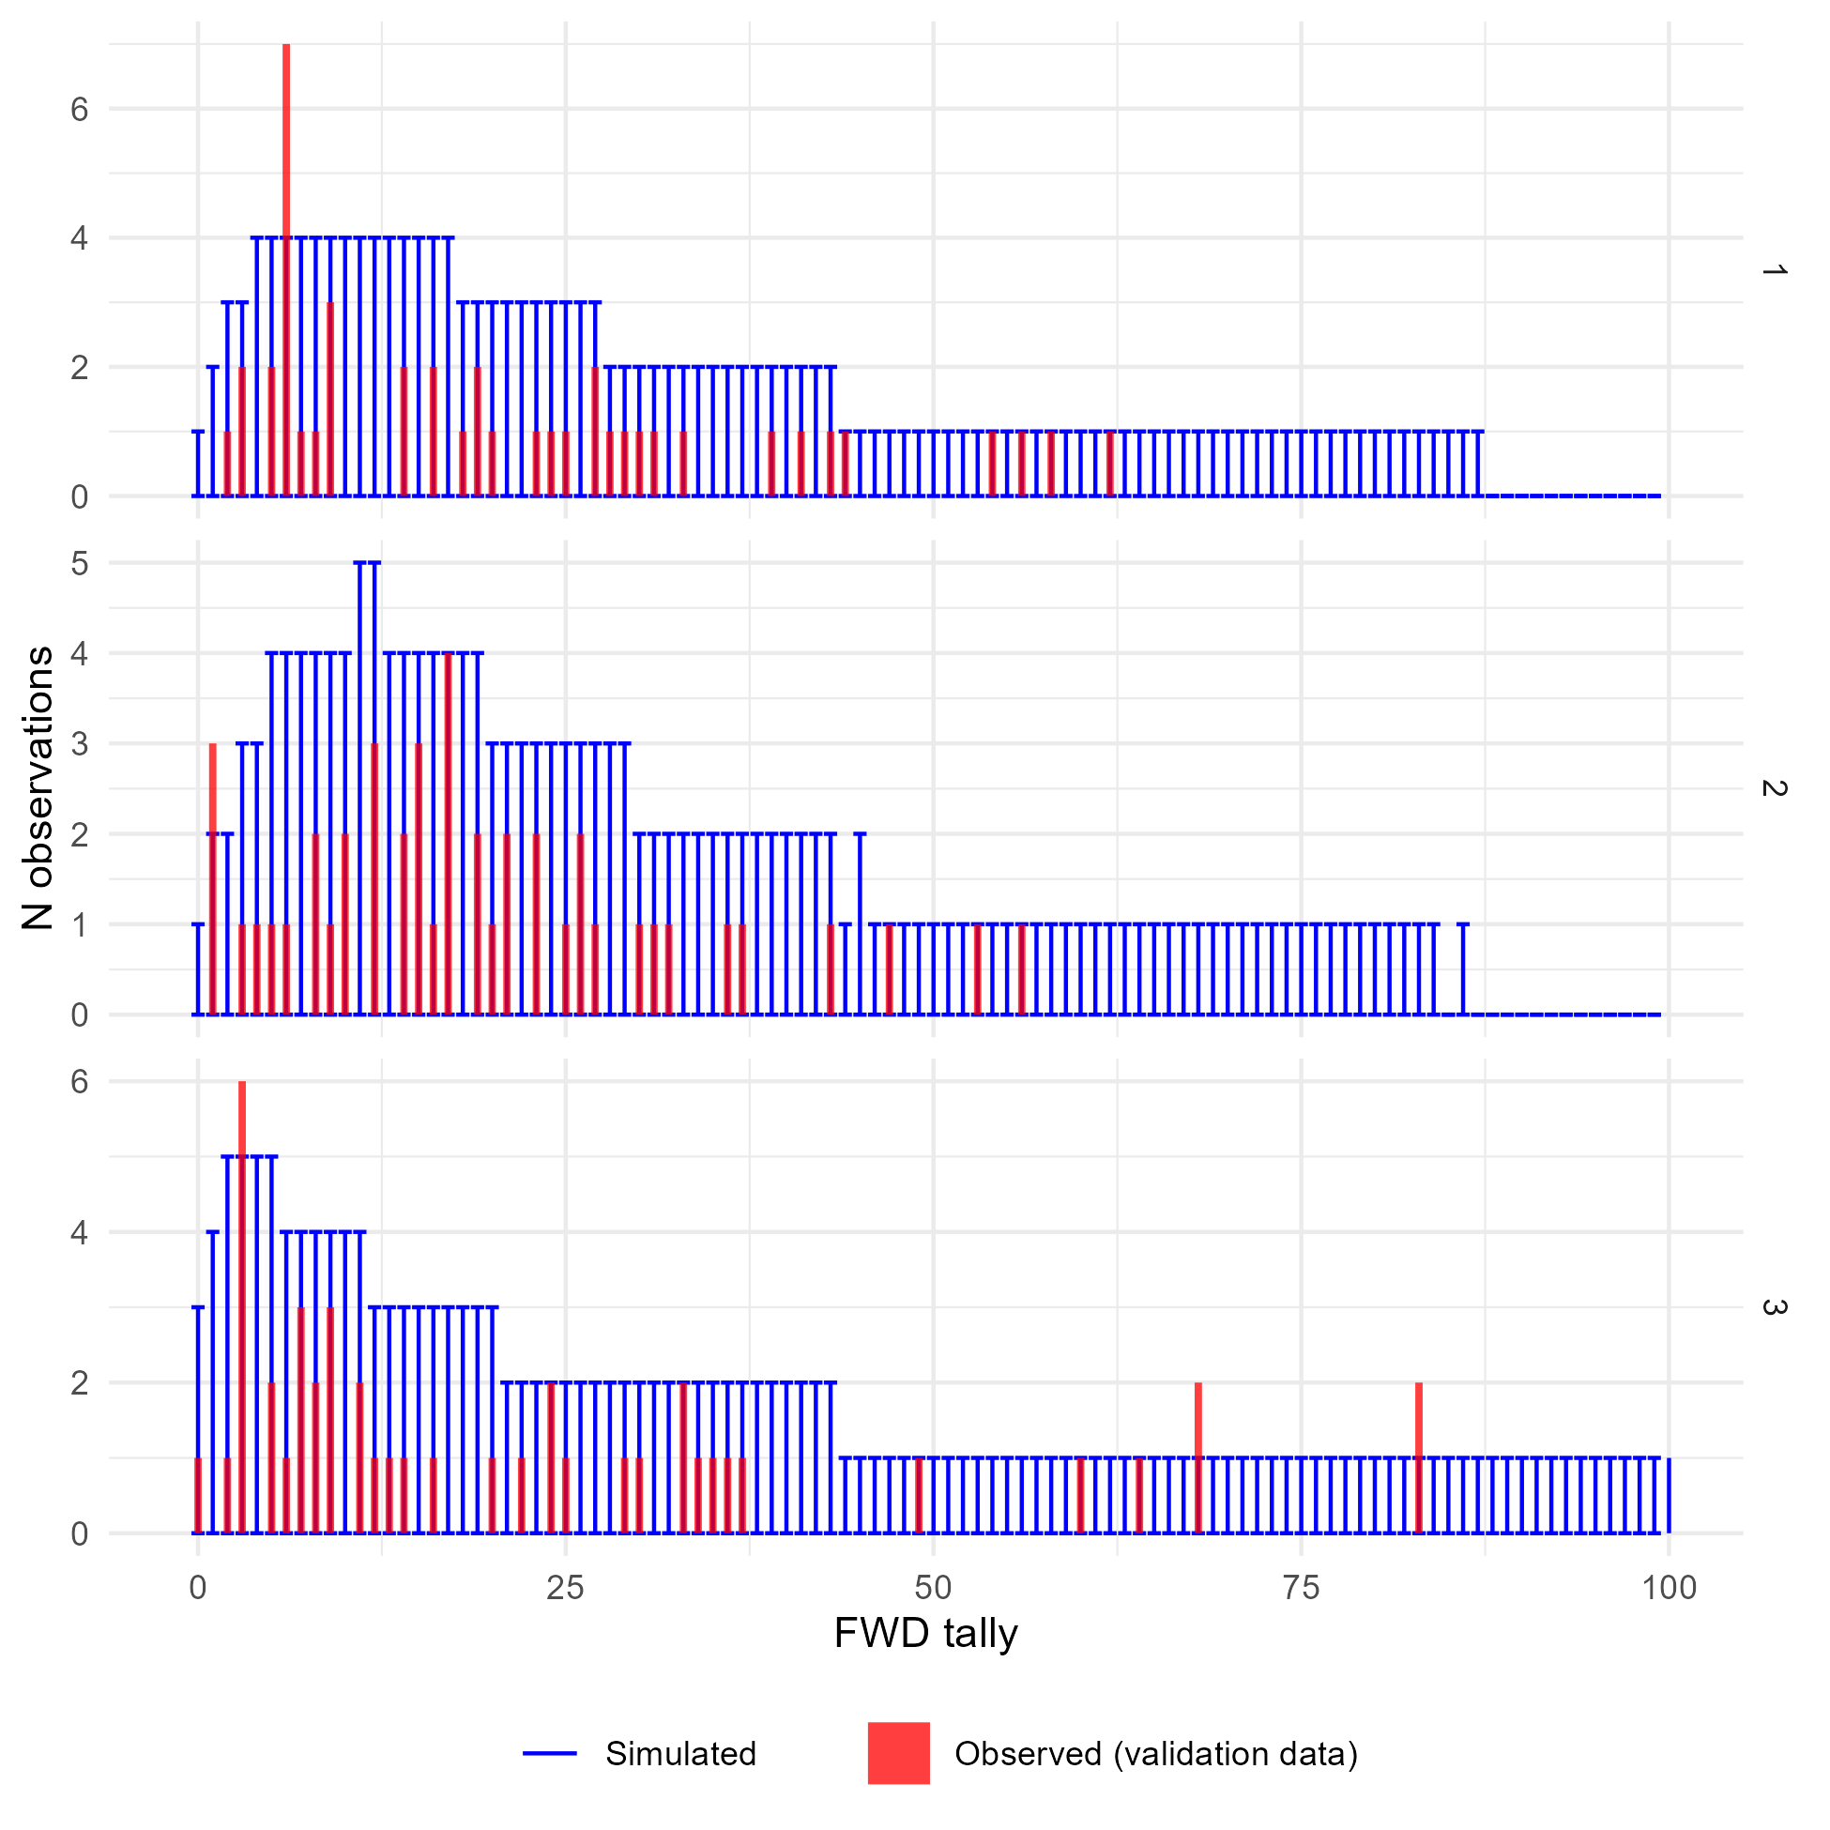
Supplementary Figure 22: Comparison of observed and simulated density distributions for the validation data and the fine woody debris tallies model. Panels show posterior predictions generated using the posterior parameter values and the validation data for each of the three submodels representing low, medium, and high drought mortality (1, 2, and 3, respectively). In each panel, the x-axis shows an (observed or simulated) tally of fine woody debris and the y-axis shows the frequency of samples from a dataset of 133 one meter subtransects having that tally (i.e., a histogram). The observed distribution of FWD tallies is plotted as the red histogram. The error bars within each tally value show the 2.5th and 97.5th percentile of the frequency of simulated samples having that tally value, across each of the 4,000 posterior draws showing the variation in model-predicted frequency distributions. The x-axis bounds have been limited to improve readability. The observed data are generally within the range of behaviors predicted by the model, though with so few data points the simulated depth distributions are noisy resulting in wide ranges for the proportion of samples falling in each bin.

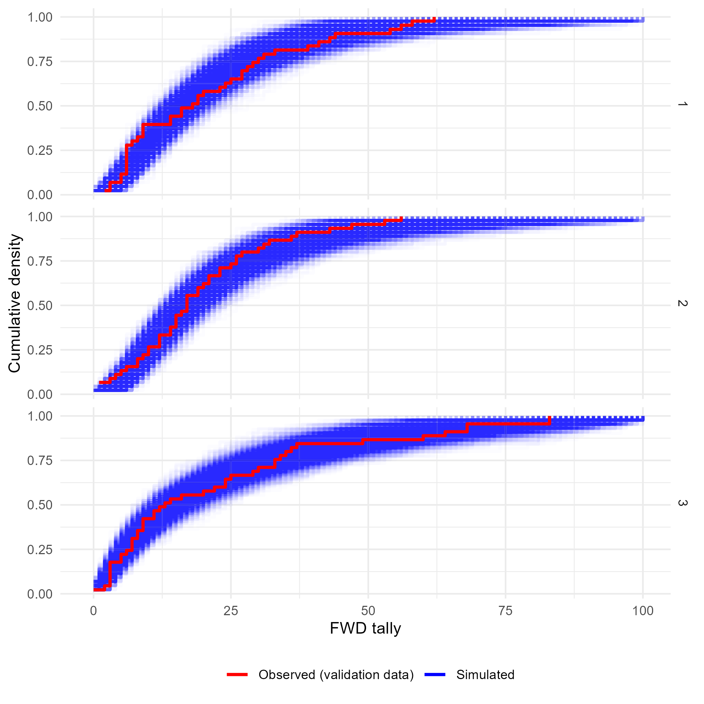
Supplementary Figure 23: Comparison of the observed and simulated cumulative density functions for the validation data and the fine woody debris tallies model. Panels show the cumulative density functions of the observed validation data (red) and each of 4,000 simulated datasets generated using posterior parameter values and random effect realizations (blue) for each of the three sub-models corresponding to low, medium, or high levels of drought mortality. The x-axis bounds have been limited to improve readability. The observed cumulative density functions fall within the range of behaviors predicted by the model, indicating good agreement between the model and reality.

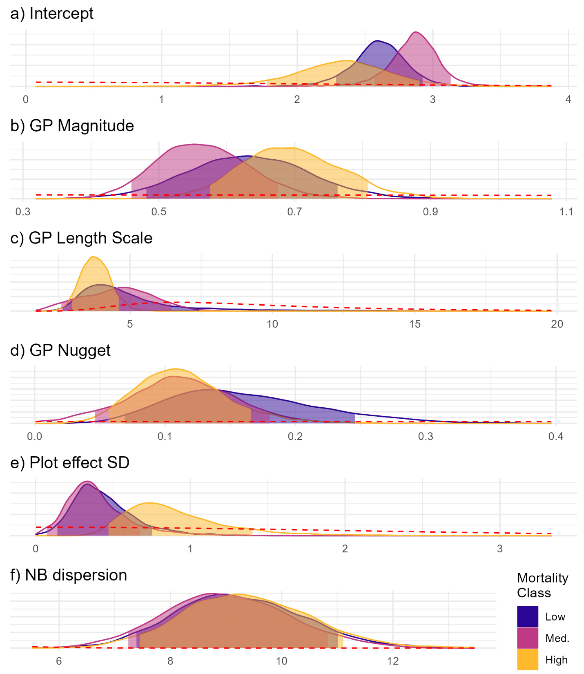
Figure 24: Posterior probability distributions for parameters of the fine woody debris tallies model. Fill colors indicate the group (drought mortality class). Each panel is for a model parameter, with the parameter value on the x-axis and the posterior probability density on the y-axis. The shaded portion of each posterior probability density curve shows an 89% credible interval for each parameter. Prior distributions for each parameter are shown as red dashed lines. All parameters appear well informed by the data except the Gaussian process length scales for the low and medium levels of drought mortality, which are only moderately well informed by the data. However, any differences between drought mortality classes are small relative to the parameter uncertainty and the 95% credible intervals of the drought mortality classes overlap for all parameters.

Parameter | Low drought mortality | Medium drought mortality | High drought mortality
Intercept (β) | 2.61 (2.29, 2.93) | 2.87 (2.57, 3.13) | 2.34 (1.77, 2.91)
GP magnitude (α) | 0.63 (0.48, 0.76) | 0.56 (0.46, 0.68) | 0.69 (0.58, 0.81)
GP length scale (ν) | 4.46 (2.62, 7.45) | 4.64 (2.58, 6.47) | 3.78 (2.96, 4.61)
GP nugget (τ) | 0.15 (0.07, 0.25) | 0.11 (0.05, 0.18) | 0.11 (0.06, 0.17)
Plot effect SD (σ) | 0.41 (0.14, 0.75) | 0.36 (0.07, 0.68) | 0.84 (0.47, 1.4)
NB Dispersion (κ) | 9.18 (7.39, 11.03) | 8.99 (7.23, 10.84) | 9.32 (7.44, 11.11)
Supplementary Table 2: Posterior parameter values for the fine woody debris tallies model.
Posterior median values for each parameter are given alongside an 89% credible interval in parentheses.

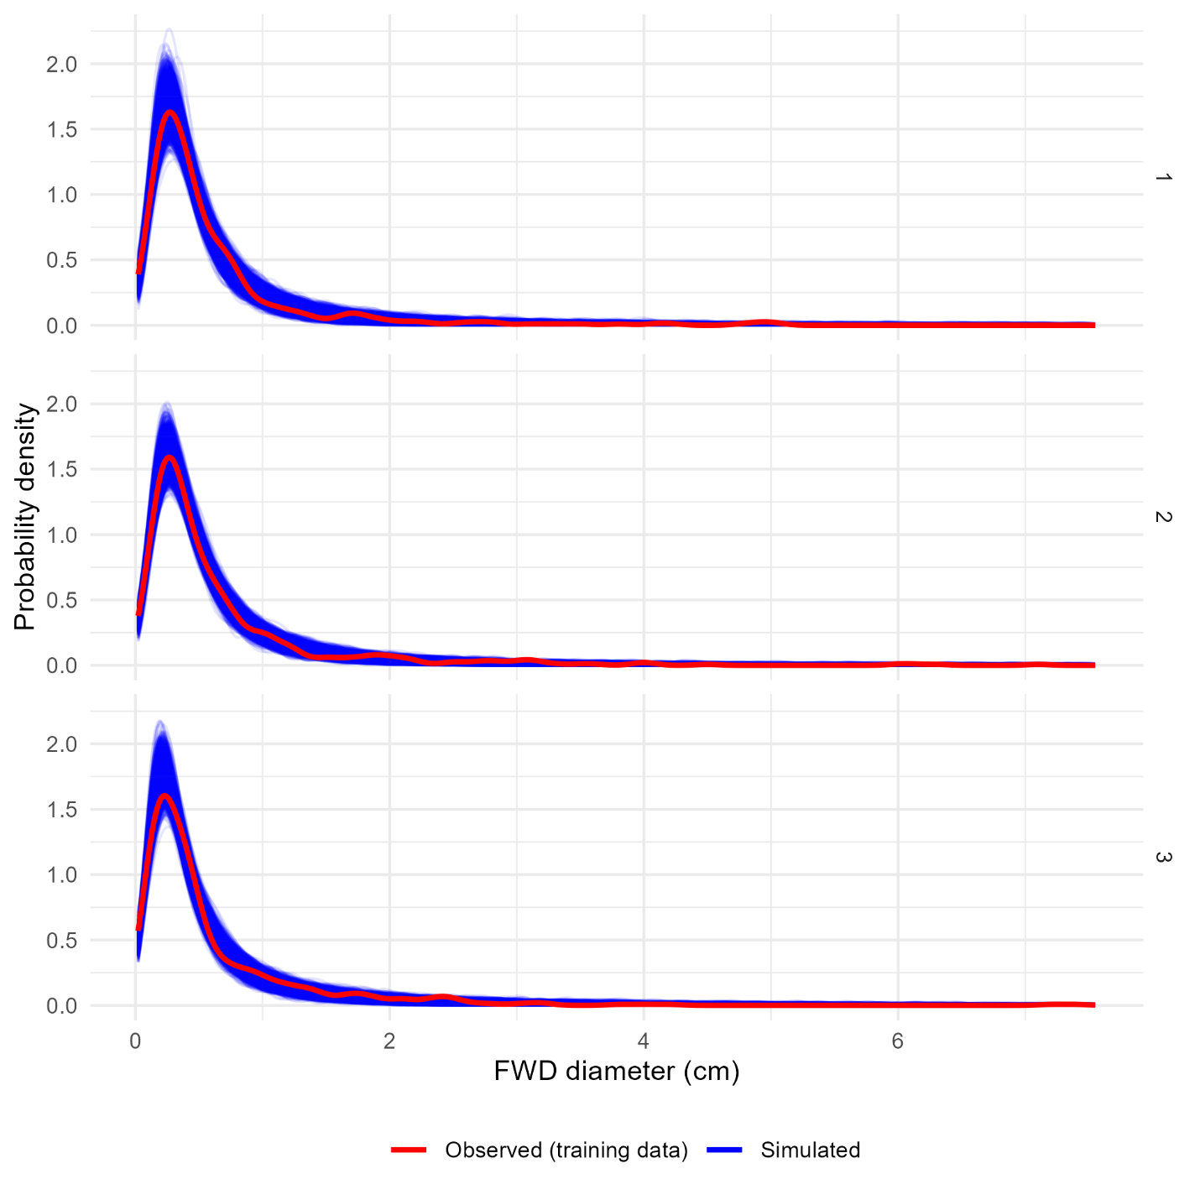
Supplementary Figure 25: Comparison of observed and simulated density distributions for the training data and the fine woody debris diameters model. Panels show the probability density functions of the observed training data (red) and each of 4,000 simulated datasets generated using posterior parameter values and random effect realizations (blue) for each of the three sub-models corresponding to low, medium, or high levels of drought mortality. For the most part, observed cumulative density functions fall within the range of behaviors predicted by the model, indicating good agreement between the model and reality.

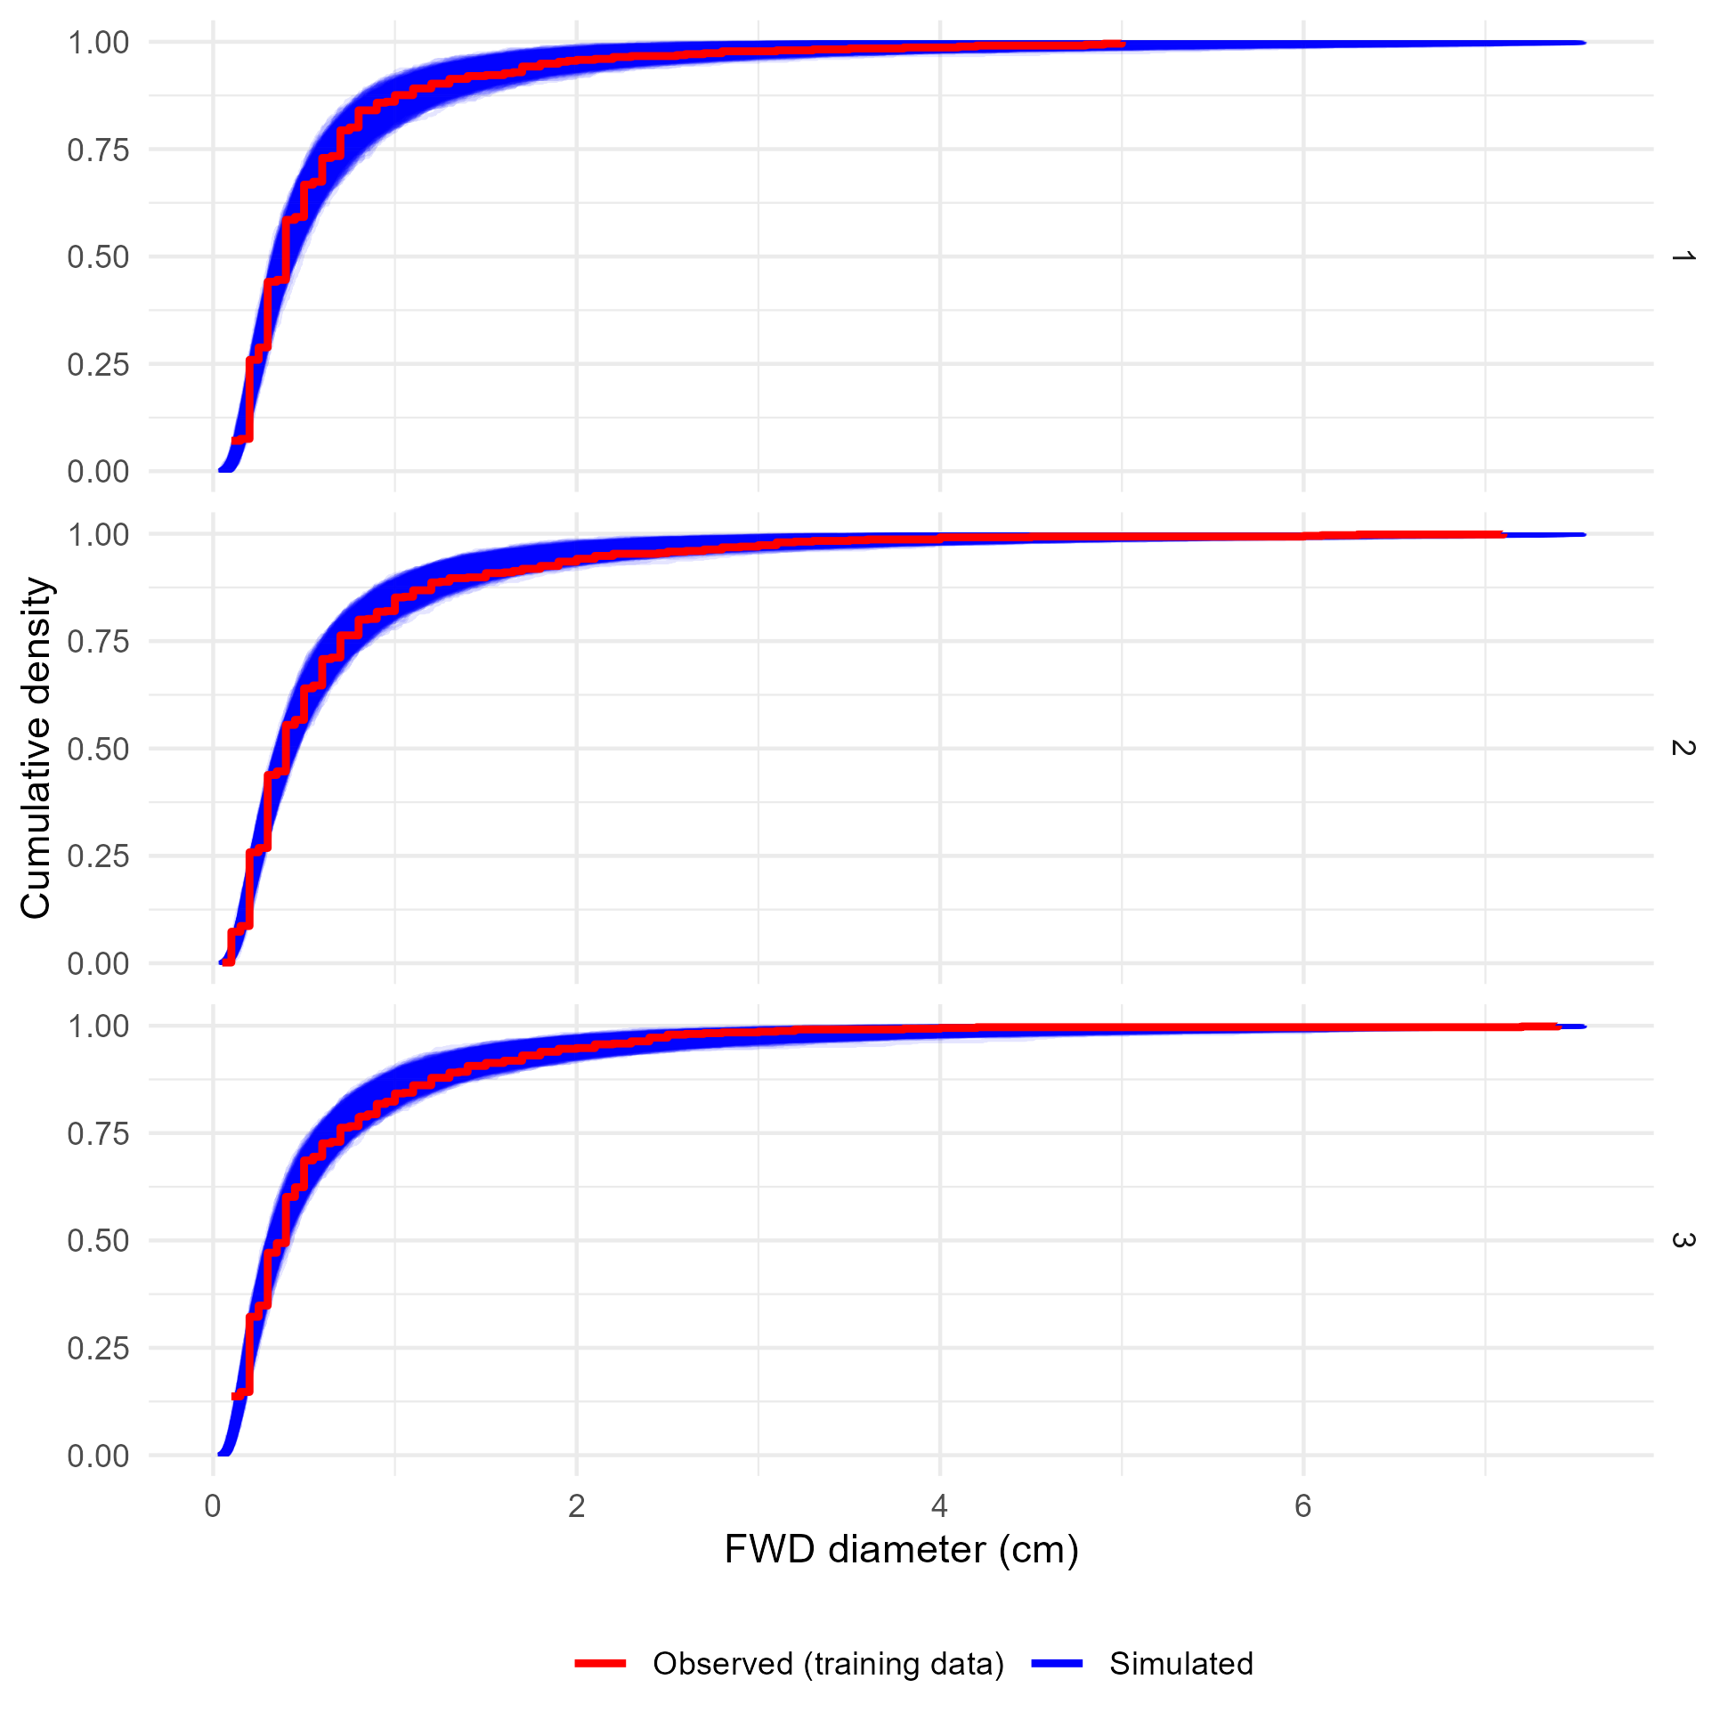
Supplementary Figure 26: Comparison of the observed and simulated cumulative density functions for the training data and the fine woody debris diameters model. Panels show the cumulative density functions of the observed training data (red) and each of 4,000 simulated datasets generated using posterior parameter values and random effect realizations (blue) for each of the three sub-models corresponding to low, medium, or high levels of drought mortality. For the most part, observed cumulative density functions fall within the range of behaviors predicted by the model, indicating good agreement between the model and reality. However, for all three levels of drought mortality the rounding of the observed diameters to the nearest 0.1 cm is evident in the pronounced stepwise character of the (red) observed cumulative density function, which at the steps falls outside or on the edge of the (blue) cumulative density functions generated from truly continuous model-simulated diameters.

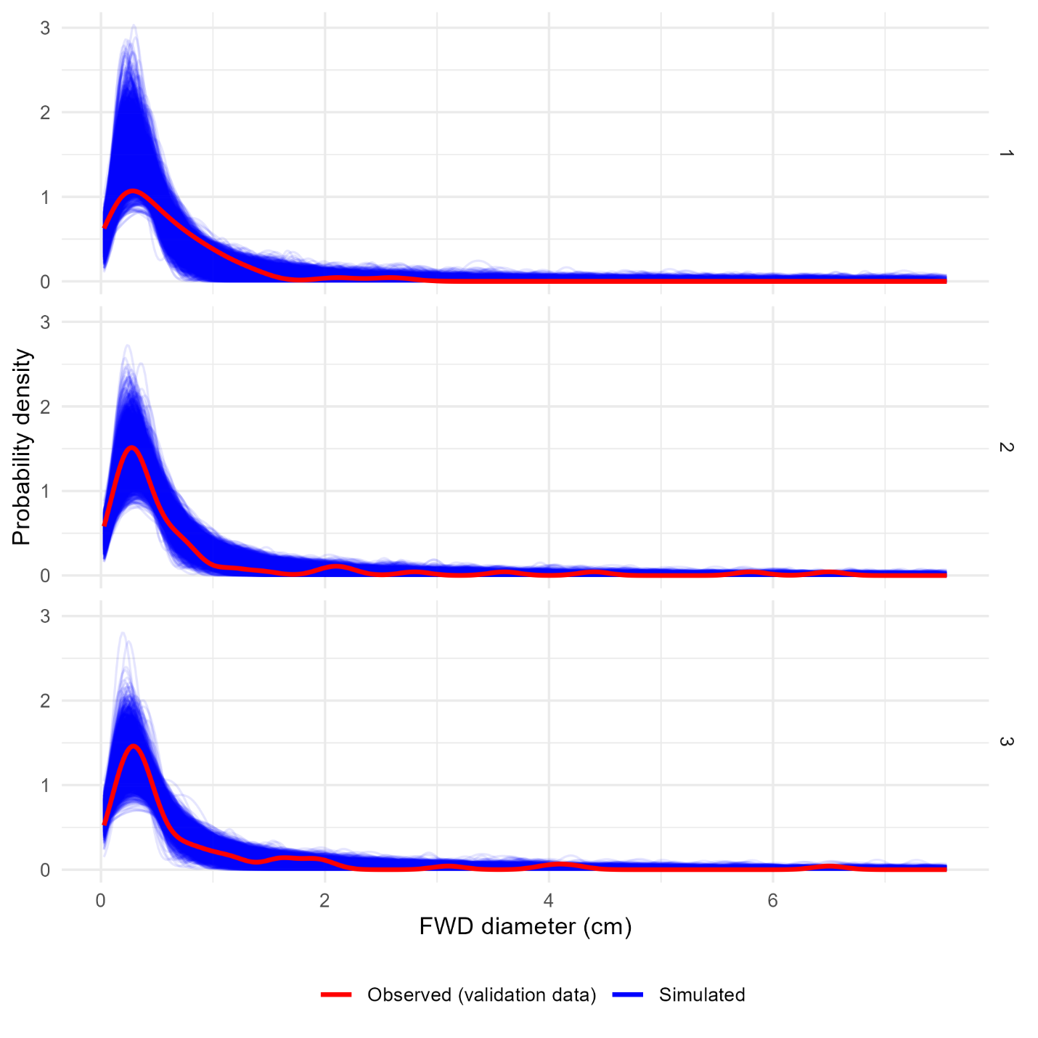
Supplementary Figure 27: Comparison of observed and simulated density distributions for the validation data and the fine woody debris diameters model. Panels show the probability density functions of the observed validation data (red) and each of 4,000 simulated datasets generated using posterior parameter values and random effect realizations (blue) for each of the three sub-models corresponding to low, medium, or high levels of drought mortality. Observed cumulative density functions fall within the range of behaviors predicted by the model, indicating good agreement between the model and reality.

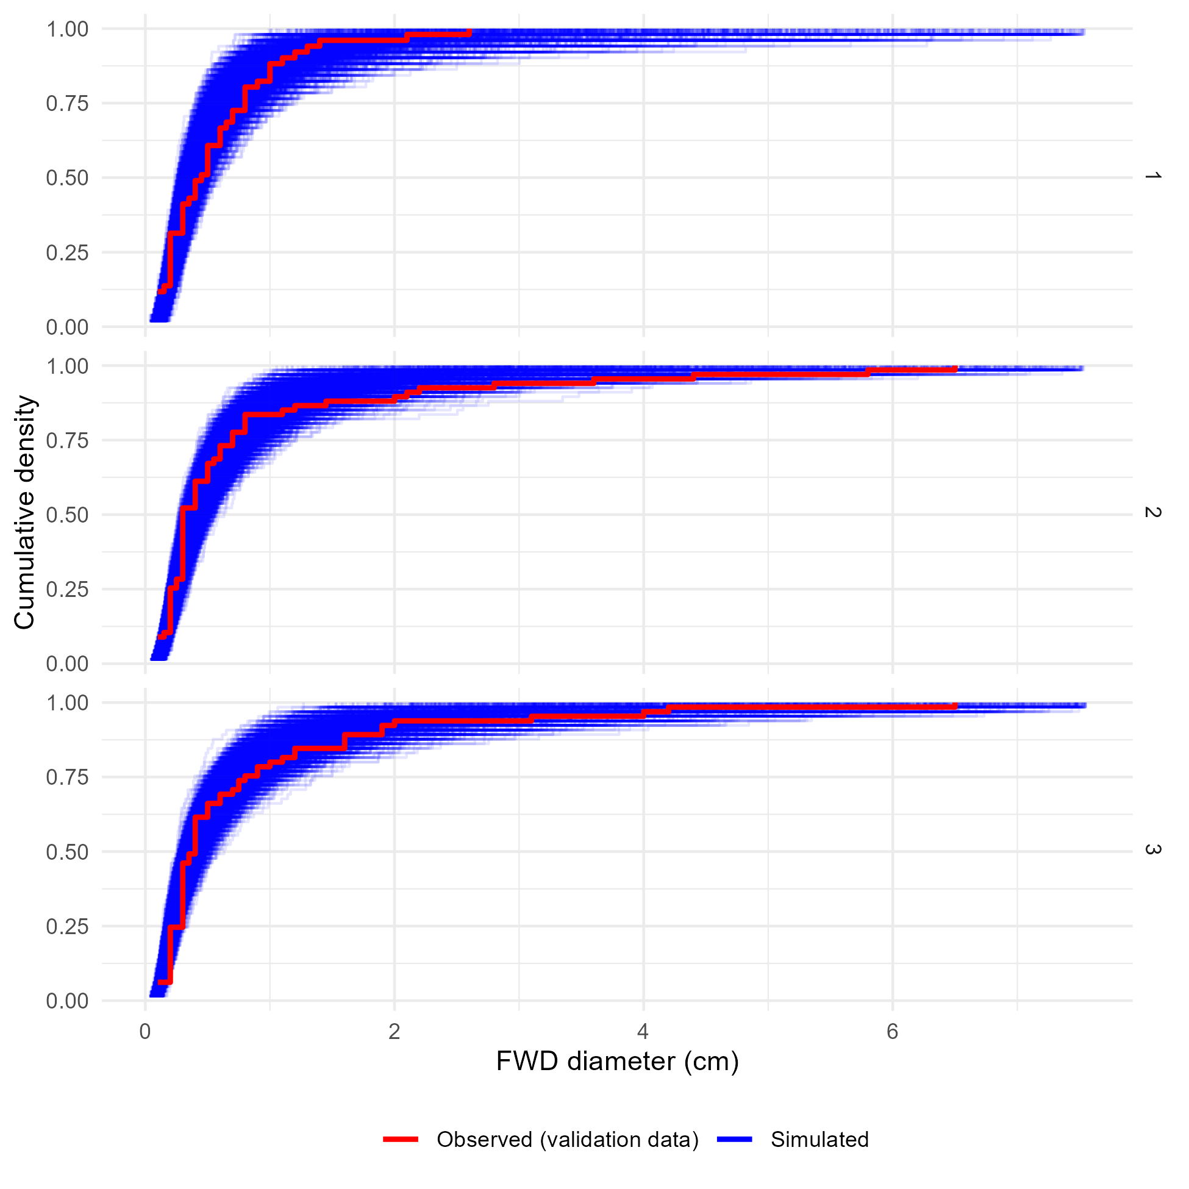
Supplementary Figure 28: Comparison of the observed and simulated cumulative density functions for the validation data and the fine woody debris diameters model. Panels show the cumulative density functions of the observed validation data (red) and each of 4,000 simulated datasets generated using posterior parameter values and random effect realizations (blue) for each of the three sub-models corresponding to low, medium, or high levels of drought mortality. For the most part, observed cumulative density functions fall within the range of behaviors predicted by the model, indicating good agreement between the model and reality. The exception, where observed behavior lies outside (or on the edge of) model predictions is that there were the observed proportion of particles with diameters equal to 0.1 cm was lower in the observed data than in most simulated datasets, for the third group (high drought mortality).

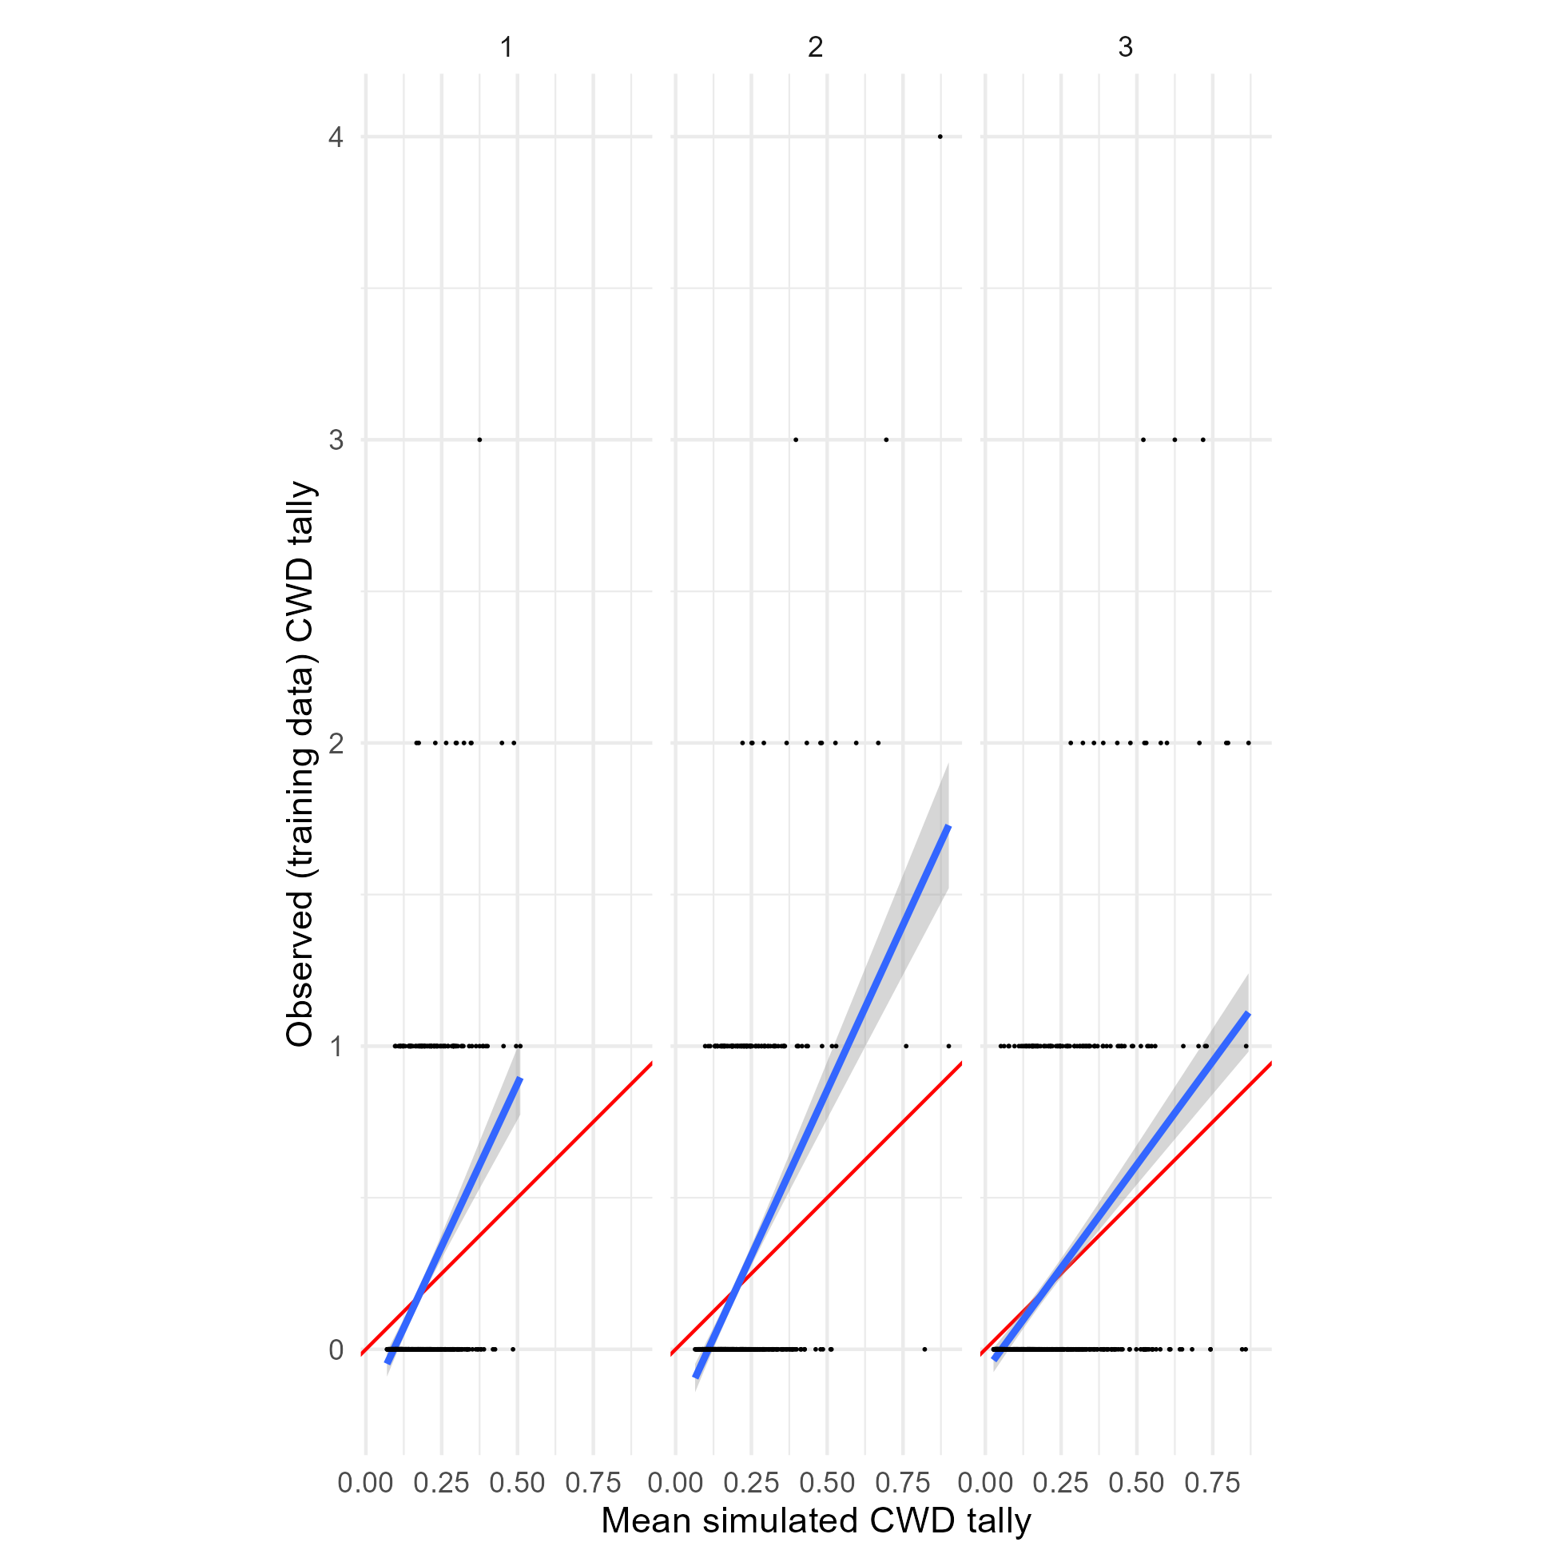
Supplementary Figure 29: Per-observation comparisons of mean predicted and observed values for the training data and the coarse woody debris tallies model. Panels show posterior predictions generated using the posterior parameter values and the training data for each of the three submodels representing low, medium, and high drought mortality (1, 2, and 3, respectively). In each panel, the posterior mean value of simulated CWD tally for each observation is on the x-axis, and the observed tally for that observation on the y-axis, with points for each observation in the training dataset. Simulated data are conditional on the posterior samples of random effect realizations. A 1:1 line (representing perfect prediction) is shown in red, and a linear fit between the simulated and observed values shown in blue. As expected, the average simulated tally for samples where the observed tally was 0 is greater than 0. However, the average simulated tally for samples where the observed tally was 1, 2, 3, or 4 consistently underpredicts the true tally.
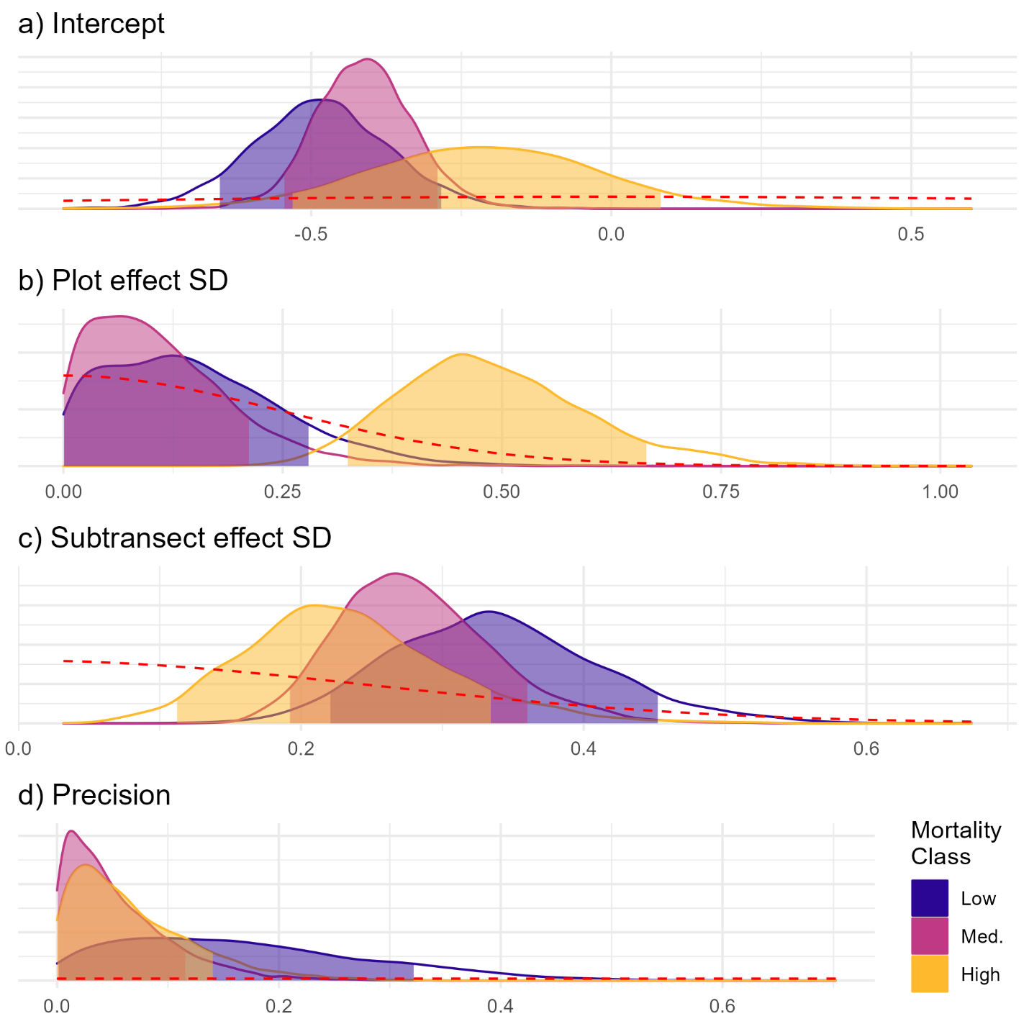
Figure 30: Posterior probability distributions for parameters of the fine woody debris diameters model. Fill colors indicate the group (drought mortality class). Each panel is for a model parameter, with the parameter value on the x-axis and the posterior probability density on the y-axis. The shaded portion of each posterior probability density curve shows an 89% credible interval for each parameter. Prior distributions for each parameter are shown as the red dashed lines. For the intercept and the precision parameter, the posterior values for each group are sharply different from the relatively broad prior distribution, indicating that the posteriors are well informed by the data rather than the prior distribution. For the standard deviation of the transect random effect, the posterior distributions for all three groups are fairly similar to the prior distribution, with the posterior only excluding values less than approximately 0.15. This suggests that the data are only weakly informing the posterior distribution for this parameter in all three sub models. For the standard deviation of the plot random effect, only the posterior for the high drought mortality group is different from the prior, indicating that for the low and medium levels of drought mortality the data were not informative about the standard deviation of the plot effect.
Parameter | Low drought mortality | Medium drought mortality | High drought mortality
Intercept (β) | -0.49 (-0.65, -0.28) | -0.41 (-0.55, -0.29) | -0.21 (-0.53, 0.08)
Plot effect SD (σ^{PLOT}) | 0.14 (0, 0.28) | 0.1 (0, 0.21) | 0.48 (0.32, 0.67)
Subtransect effect SD (σ^{SUBTRANSECT}) | 0.33 (0.22, 0.45) | 0.28 (0.19, 0.36) | 0.23 (0.11, 0.33)
Precision (φ) | 0.15 (0, 0.32) | 0.04 (0, 0.12) | 0.05 (0, 0.14)
Supplementary Table 3: Posterior parameter values for the fine woody debris diameters model.
Posterior median values for each parameter are given alongside an 89% credible interval in parentheses.

